GORSLEY GOFFS PRIMARY SCHOOL – MEDIUM TERM PLANNING
National Curriculum

- In History we will investigate sources of information which tell us about the Titanic and the people on board. We will also investigate what life was like on the Titanic for each of the classes and introduce the people who were on board.

In Art we will use perspective and foreshortening to create a picture of the Titanic. We will also create a 3-D model of the Titanic using clay or recycled materials.

In Geography we will use longitude and latitude to locate important places in the Titanic’s journey.

As Scientists we will be finding out living things and how they can be classified both broadly and specifically into groups. We will use classification keys to find out about animals and plants that are unknown to us. We will also explore what a microorganism is and carry out an investigation to find out what environment is best or growing microorganisms.

In English we will be using our topic of the Titanic to create descriptive pieces, newspaper reports of the event and diary entries as if we were a passenger on board. We will also be writing a non-chronological report. In grammar we will be learning to use the active and passive voice as well as figurative devices.

In Mathematics we will be covering the following units:
- Place Value, ordering and rounding, including multiplying and dividing decimals by 10, 100, 1000
- Use negative numbers in context
- The four operations
- Long multiplication and Long division
- Common factors, multiples and prime numbers
- Order of operations

In Drama we will be making links with our Titanic theme and role playing as passengers onboard. Later we will Study Shakespeare’s Romeo and Juliet. We will be exploring elements of the play and we will learn about the characters and the plot.

In PE we will develop our tactical awareness and coordination skills when playing hockey. We will also be working on developing our gymnastic skills.

In French we will learn the nouns and definite articles/determiners for 10 school subjects. Children will have the knowledge and skills to talk about the subjects they like and dislike at school.

In RE we will be looking at what it means for Christians to believe that God is holy and loving as well as the beliefs of Hindus.

In Computing we will be looking at how we communicate safely and responsibly when using the Internet.as well as how networks work.

In PSHE we will be studying the topic ‘Keeping Safe’ and looking at water safety.

In Music we will learn and study the song ‘Dona nobis pacem’. It is a round in three parts that is set to a short prayer for peace. It is in Latin and comes from the Agnus Dei of a Roman Catholic Mass. In this unit, pupils will explore pulse work in 3-time, learn to sing the song as a round, learn about texture in music, and compare music with different textures. They will create their own pieces using given rhythms and chords, working from stick notation.

Y6 – MISS VOSS
AUTUMN 1 – THE TITANIC

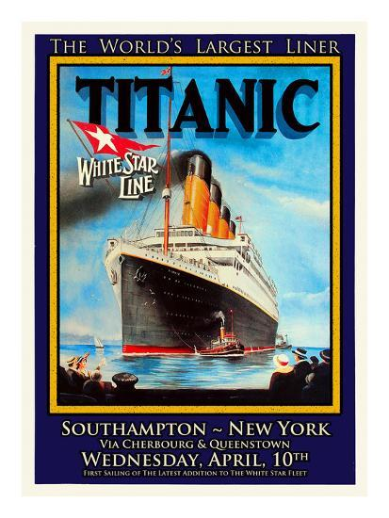
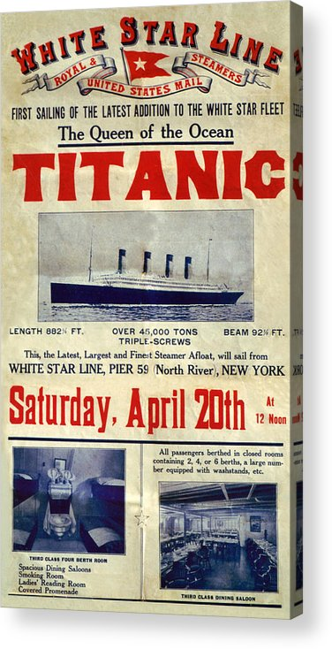

THINGS TO REMEMBER:
- PE will be on a Monday (indoor) and a Friday (outdoor). Please ensure your child wears their PE kit on both days.
- Homework will be issued on a Thursday and will be due on the following Tuesday.
- Reading records should be brought into school on a daily basis.
- Children should practise their Rainbow maths for a few minutes each day
Websites:
https://www.ttrockstars.com/
https://www.mymaths.co.uk/
https://www.spellingshed.com/en-us

