
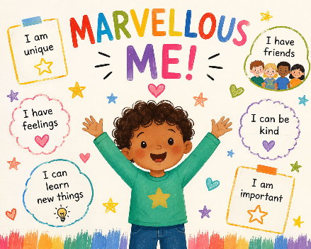
Please provide a named pair of wellies which can be left in school.
Acorns Autumn 2026
Reception

Communication, Language and Literacy
This term will be all about getting to know each other, encouraging the children to share information about themselves and their experiences.
Throughout the week we will be, encouraging the development of children’s emergent writing skills. Throughout the rest of the week, our main focus will be on phonics, learning different phonemes (sounds) and their associated graphemes (written representations), and how we can blend them together to create words, aiding both reading and writing skills. In all adult-led activities, the children will be encouraged to hold a pencil correctly. This will allow the children to focus on forming letters correctly.
How can I help at home?
Share stories and songs together. Spend time playing games and baking, talking about what you are doing.
When reading books and phonics are sent home, please share together as regularly as possible.
Mathematics
The focus this term will be on numbers to 5, developing children’s understanding of the five key counting principles in mathematics. Using 5-frames, children will develop subitising skills—the ability to recognise small quantities without counting. Each day, children will take part in meaningful mathematical activities, supported by the BBC’s Numberblocks to bring numbers and mathematical concepts to life. Activities will encourage problem-solving, while precise mathematical language will be modelled to help children communicate and apply their understanding across different contexts.
Characteristics of Effective Learning (CoEL)
Engagement
We will encourage children to explore and discover by modelling our own curiosity and enthusiasm. Resources and experiences will reflect children’s interests and developmental needs, providing meaningful challenges and opportunities for first-hand learning.
Motivation
Children will be encouraged to make choices about what and how they learn, with the time and freedom to become deeply involved in activities. We will ensure every child has opportunities to contribute and participate.
Thinking
We will model curiosity and show that adults do not always have the answers. Children will be encouraged to ask questions, explore ideas and consider different possibilities.
Learning to Learn
Our whole-school focus on Responsibility will support children in becoming responsible members of the class. Together, we will create a Class Charter to help everyone learn and work effectively.

Personal, Social and Emotional Development
The focus will be on settling into school, getting to know one another and talking about feelings. Through weekly Being Me in My World lessons, children will explore belonging, similarities and differences, cooperation, kindness, gentle hands and responsibility.
Physical Development
Weekly PE lessons will develop fundamental movement skills such as running, jumping and skipping. Children will also develop coordination and control through topic-related activities and outdoor play.
Understanding the World
Children will explore past and present events in their own and family lives, comparing how things have changed over time. They will compare familiar environments, including home, school and nursery, and learn about staying safe and healthy, the human body and the five senses. We will think about how the weather changes with the seasons.
Expressive Arts and Design
Children will explore self-portraits, family portraits and autumn-inspired artwork, with daily opportunities for independent creativity. Later in the term, festive activities will provide further opportunities to create. We will learn songs and poems, explore rhythm and syllables using percussion instruments, and develop our role-play through a Home Corner.

