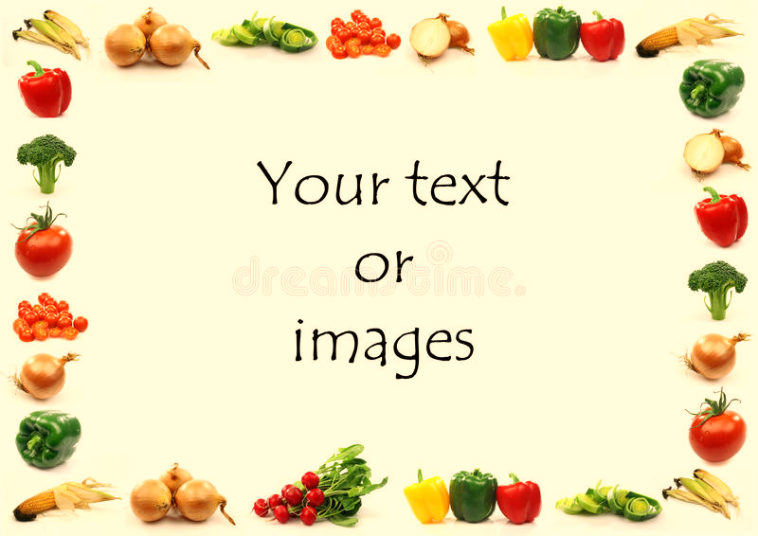

Gorsley Goffs Primary School Lunch Menu
WEEK 3 Menu
Weeks commencing 27th April & 18th May 2026

 | Monday | Tuesday | Wednesday | Thursday | Friday
Main Meal | Pasta twist with tomato, basil and mascarpone sauce | Sausage plait with homemade tomato sauce | Roast chicken with sage and onion stuffing and gravy | Chilli con carne with rice | Fish cakes with homemade tomato sauce
Vegetarian Meal | Pasta twist with tomato, basil and mascarpone sauce | Vegetarian sausage plait with homemade tomato sauce | Roast Quorn with sage and onion stuffing and gravy | Baked potato with grated cheese and baked beans | Halloumi fingers with homemade tomato sauce
Vegetables | Cauliflower  Green Beans | New Potato  Broccoli  Peas | Roast Potato  Carrots  Garden Peas | Sweetcorn  Green beans | Roasted diced potato  Carrots  Courgettes
Pudding | Cooked fruits with crunchy topping  Fresh Fruit | Cherry cake  Fresh Fruit | Raspberry yoghurt  Fresh Fruit | Fruit salad  Fresh Fruit | Ice Cream  Fresh Fruit
DAIRY AND GLUTEN FREE MEALS ARE ALWAYS AVAILABLE TO MEET DIETARY REQUIREMENTS

