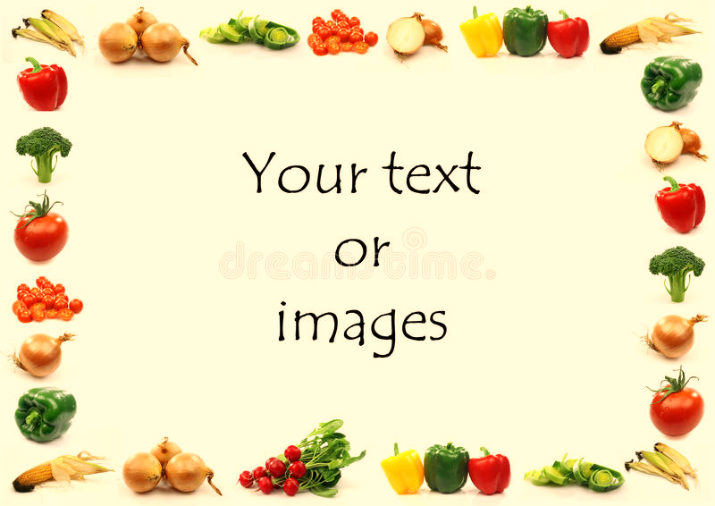
Gorsley Goffs Primary School Lunch Menu
WEEK 2 Menu
Weeks commencing 20th April & 11th May 2026

 | Monday | Tuesday | Wednesday | Thursday | Friday
Main Meal | Beef lasagne | Chicken korma with rice and naan bread | Toad in the hole with gravy | Homemade pepperoni pizza | Salmon fish fingers with tomato sauce and skin on fries
Vegetarian Meal | Roasted vegetables lasagne | Baked potato with grated cheese and baked beans | Vegetarian toad in the hole with gravy | Homemade margarita pizza | Halloumi fingers with tomato sauce and skin on fries
Vegetables | Courgette  Peas | Cauliflower  Green beans | Baby potato  Carrots  Garden Peas | Salad bar  Potato Wedges | Broccoli  Green Beans
Pudding | Berry fool  Fresh Fruit | Fruit scones  Fresh Fruit | Blueberry cake  Fresh Fruit | Summer fruits yoghurt  Fresh Fruit | Apple crumble  Fresh Fruit
DAIRY AND GLUTEN FREE MEALS ARE ALWAYS AVAILABLE TO MEET DIETARY REQUIREMENTS

