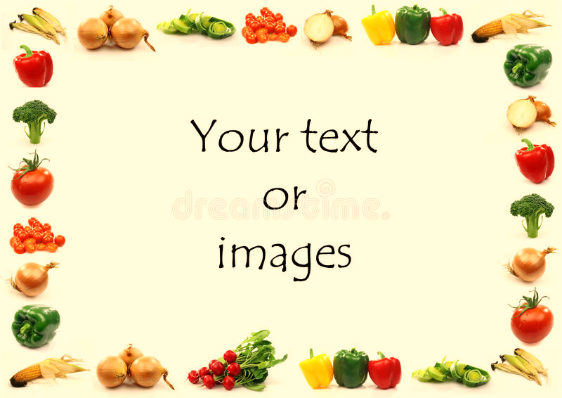
Gorsley Goffs Primary School Lunch Menu
WEEK 1 Menu
Weeks commencing 13th April & 04th May 2026

 | Monday | Tuesday | Wednesday | Thursday | Friday
Main Meal | 3 Cheese macaroni with garlic bread | Chicken ragu with rice | Roast pork with sage & onion stuffing, apple sauce and gravy | Meatballs with tomato sauce and spaghetti | Homemade fish fingers with skin on fries
Vegetarian Meal | Pasta with tomato and fresh herbs sauce with garlic bread | Baked potato with grated cheese or tuna and sweetcorn | Roast quorn with sage & onion stuffing, apple sauce and gravy | Vegetarian meatballs with tomato sauce and spaghetti | Homemade halloumi fingers with skin on fries
Vegetables | Carrots  Green Beans | Broccoli  Courgettes | Roast Potato  Carrots  Peas | Sweetcorn  Cauliflower | Baked Beans  Garden Peas
Pudding | Cherry yoghurt  Fresh Fruit | Apple and cinnamon crumble  Fresh Fruit | Mango yoghurt  Fresh Fruit | Lemon and raspberry cake  Fresh Fruit | Cooked apple and berries  Fresh Fruit
DAIRY AND GLUTEN FREE MEALS ARE ALWAYS AVAILABLE TO MEET DIETARY REQUIREMENTS

