GORSLEY GOFFS PRIMARY SCHOOL – MEDIUM TERM PLANNING
Y6 – MISS VOSS
National Curriculum
As Historians we will consider similarities and differences between ancient religions and different religions today. We will also establish a chronological context of the Maya and explore different sources of evidence about the Maya.

As Geographers we will be studying the physical features of Mexico and how they affect the human activity as well as the main physical and human characteristics of countries in North America. We will be exploring physical geography, including looking at topographic maps.

As Design Technologists we will design, make and evaluate a model of a Maya temple. Furthermore, we will make our own salsa to go with a tortilla recipe.

As Artists we will be studying Mayan art and artefacts. We will also explore the Bonampak murals and recreate a Mayan mask.

As Scientists we will be studying evolution and inheritance and identifying how characteristics are passed down from parent to child. We will study how natural selection and survival of the fittest leads to the evolution of species who have more advantageous characteristic for future survival.

In PE we will be developing methods to pass and defend in netball, and we will learn to recognise and suggest patterns of play which will increase chances of success. In gymnastics, we will develop our balance, travelling and jumps to create an imaginative sequence to perform to the class.

As Writers we will study myths and legends from the ancient Maya civilisation. They will then learn to use a variety of sentence types and we will look at a range of punctuation, which includes colons and semicolons. We will use the text ‘The Rain Player’ to write instructions for pok-a-tok, a missing scene, and a conduct debates. We will study the work of Charles Darwin and create an informative biography following research.

As Mathematicians we will be covering the following units:
- Know angle sums for pentagons, hexagons, and octagons, and use this fact to calculate missing angles;
- Illustrate and name parts of circles, including radius, diameter and circumference and know that the diameter is twice the radius;
- Calculate and interpret the mean as an average;
- Interpret and construct pie charts and use these to solve problems;
- Read and plot coordinates in quadrants
- Translate, reflect and rotate shapes in quadrants

In French we will be learning the knowledge and skills to present both orally and in written form about where we live and which rooms we have and do not have in our homes in French. This is a unit that focuses on recycling previously learnt grammar, using it with new vocabulary, conjunctions and grammar, demonstrating a growing ability to create independent responses.

In RE we will consider what kind of King was Jesus. We will explore how Jesus led by example and inspired Christians to help make the world a better place.

In Music we will listen to the song You to me are everything by The Real Thing – a British soul group formed in the 1970s. During this unit, pupils will explore the key musical features of this track and develop an understanding of the term ‘cover version’.

In Computing we will be exploring what makes a good website before designing and creating a home page for a website using Publisher. We will learn how and why navigation pages are used on websites and about the law of Copyright.

SPRING 2025 – The Ancient Maya Civilisation
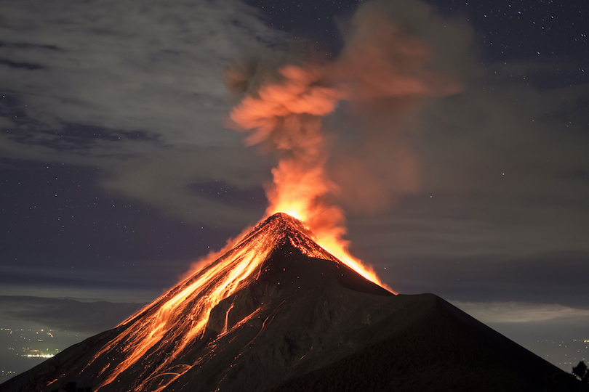
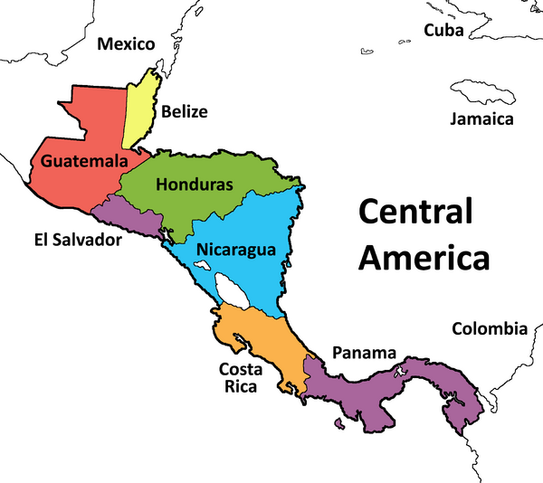
- PE will be on Wednesdays
- Homework will be issued on a Thursday and will be due on the following Tuesday.
- Reading records should be brought into school on a daily basis.
Websites:
https://www.ttrockstars.com/

THINGS TO REMEMBER:

