GORSLEY GOFFS PRIMARY SCHOOL – MEDIUM TERM PLANNING
Y6 – Miss Voss
National Curriculum
As Geographers we will be studying the structure of the Earth and tectonic plates that cover the Earth’s crust. We will explain the structure of a volcano and describe what happens when a volcano erupts and its effect on the surrounding environment. We will be exploring the human and physical features of land around a volcano and why people would choose to live near a volcano. We will also be finding out where volcanoes are on a world map and finding links with their locations.

As Scientists we will be finding out living things and how they can be classified both broadly and specifically into groups. We will use classification keys to find out about animals and plants that are unknown to us. We will also explore what a microorganism is and carry out an investigation to find out what environment is best or growing microorganisms.

In PE we will be developing methods to outwit opponents in football, and we will learn to recognise and suggest patterns of play, which will increase chances of success. We will study dance through the ages and learn a dance from each decade since the 1960s to present day. We will perform these dances using a range of movement patterns both individually and as part of a group.

In Drama we will be completing a play study: Bill’s New Frock by Anne Fine. We will cover character analysis, set design, directing and group improvisation.

As Writers we will study the fictional planet of Pandora, which was famously used in the film Avatar, and create a detailed description of the planet and its inhabitants. We will also write a non-chronological report about the planet as well as a persuasive text to encourage people to visit it. Children will learn to use a variety of sentence types, and we will look at a range of punctuation, which includes brackets, dashes, commas, colons and semicolons.

As Mathematicians we will be covering the following units:
- Decimals and percentages;
- Algebra
- Ratio

In French we will be learning about the school day: we will learn to say in French what subjects we like and don’t enjoy and at what time we study them at school.

In RE we will begin to explore the following questions: What matters most to Humanists and Christians and making comparisons between their beliefs and actions.

In Music we will be studying different genres of music and creating PowerPoints to present to the class what we have learnt about three of our chosen genres.

In Computing we will be learning how to create a web page and use design tools to ensure that our page is interesting and well organised.
SPRING 2025 – Volcanoes
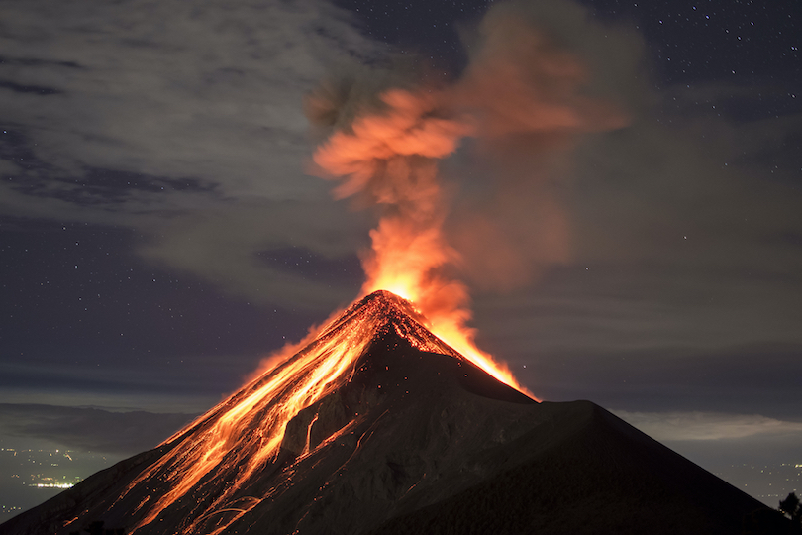
- The children need to read five times a week and they need to practise their spellings on Spelling Shed.
- Homework will be issued on a Thursday and will be due on the following Tuesday.
- Reading records should be brought into school on a daily basis.
- PE will be on Mondays and Fridays.
Websites:
https://www.ttrockstars.com/
https://www.mymaths.co.uk/
https://www.edshed.com/en-gb/logout

THINGS TO REMEMBER:
