GORSLEY GOFFS PRIMARY SCHOOL – MEDIUM TERM PLANNING
National Curriculum

- In History we will investigate sources of information which tell us about the Titanic and the people on board. We will also investigate what life was like aboard the Titanic for each of the classes and introduce the people who were on board.

In Art we will use perspective and foreshortening to create a picture of the Titanic. We will also create a 3-D model of the Titanic using clay or recycled materials.

In Geography we will use longitude and latitude to locate important places in the Titanic’s journey.

In Science we will be learning about how light travels and how shadows are formed.

In English we will be using our topic of the Titanic to create descriptive pieces, newspaper reports of the event and diary entries as if we were a passenger on board. We will also be writing a non-chronological report. In grammar we will be learning to use the active and passive voice as well as figurative devices.

In Mathematics we will be covering the following units:
- Place Value, ordering and rounding, including multiplying and dividing decimals by 10, 100, 1000
- Use negative numbers in context
- The four operations
- Long multiplication and Long division
- Common factors, multiples and prime numbers
- Order of operations

In Drama we will be making links with our Titanic theme and role playing as passengers onboard. Later we will Study Shakespeare’s Romeo and Juliet. We will be exploring elements of the play and we will learn about the characters and the plot.

In PE we will develop our tactical awareness when playing tag rugby. We will also focus on developing the fundamentals of movement: agility, balance and coordination.

In Music we will be learning all about the guitar this half term: labeling parts, learning about basic guitar physics, different types of guitar, and listening to some different styles of guitar music and playing. We will learn simple versions of a few chords including G, D, A, A minor, and E minor. We will learn some chord sequences particularly focusing on the Beatles song With a Little Help From My Friends’ using guitar, garage band and tuned instruments. If you have a guitar and are happy to bring it into school each Wednesday then that would be great.

In French we will working on improving our pronunciation and ensuring that we are confident with 18 key phonemes. We will practice our translation skills as well as speaking skills.

In RE we will be looking at what it means for Christians to believe that God is holy and loving.

In Computing we will be looking at how we communicate safely and responsibly when using the Internet.as well as hpw networks work.

In PSHE we will be studying the topic Being Me in My World.
Y6 – MISS VOSS
AUTUMN 1 – THE TITANIC

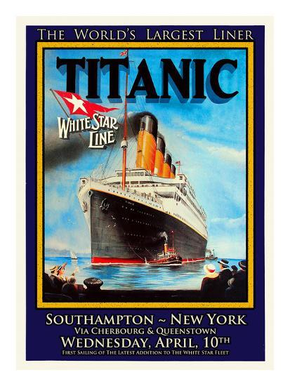

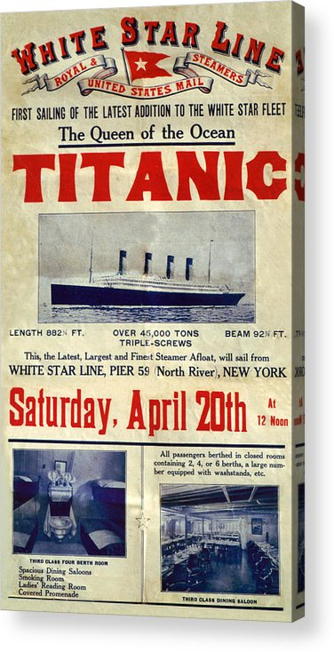

THINGS TO REMEMBER:
- PE will be on a Monday (indoor) and a Friday (outdoor). Please ensure your child wears their PE kit on both days.
- Homework will be issued on a Thursday and will be due on the following Tuesday.
- Reading records should be brought into school on a daily basis.
- Children should practise their Rainbow maths for a few minutes each day
Websites:
https://www.ttrockstars.com/
https://www.mymaths.co.uk/
https://www.spellingshed.com/en-us

