GORSLEY GOFFS PRIMARY SCHOOL – MEDIUM TERM PLANNING
National Curriculum

- As Historians we will investigate the causes of the First World War. We will investigate what life was like on the Western Front. We will study the use of propaganda and censorship as well as military advancements. We will explore how the alliance system created tension in Europe. We will also explore the diversity of nations that took part in the war and identify the consequences of the Treaty of Versailles.

As Artists and in Design Technology we will study paintings from the First World War. We will create our own propaganda poster to encourage recruitment to the armed services. We will also create our own shoebox trench. The children will create a war-based piece of artwork using silhouette. We will also make a trench cake and discuss the impact of rationing on food in wartime.

As Geographers we will use maps and atlases to locate the countries involved in the First World War. We will also use maps to locate the battles of the Somme and Passchendaele. We will compare and contrast a map of Europe from 1914 to today.

As Scientists we will be finding out about electricity. We will learn about series and parallel circuits as well as the symbols used for each of the components of a circuit. We will make our own circuit based device.

As Writers we will be using a range of text types to develop our understanding of the different writing styles and structures. We will be using the texts ‘Stay where you are and then leave’ by John Boyne as a stimulus to study this significant turning point in British history. We will use first-hand accounts, letters and diary entries to support the children’s writing of a postcard from the trenches. We will also study poetry from the First World War and the children will complete their own war poem.

As Mathematicians we will be covering the following units:
- Converting, reducing, comparing and ordering fractions.
- We will learn to multiply simple pairs of proper fractions and to divide a fraction by a whole number.
- Use and convert between metric units of length and weight including understanding imperial units.

In Drama we will be studying Shakespeare’s Romeo and Juliet. We will be exploring elements of the play and we will learn about the characters and the plot.
In PE we will develop our tactical awareness when playing hockey. We will also perform short dance sequences to music that illustrates the events of WW1
In Music we will aim to include a short melody based on ‘The Last Post’ and to combine our Last Post compositions (recorded using notation and garage band app) with our battle soundscapes. We will use John McCrae’s poem ‘In Flanders Fields’ to form a comprehensive creative performance.

In French we will recognise and use fruit and artistic vocabulary and count from 31 to 100.

In RE we will be exploring the question: Why is the Torah so important to Jewish people?
Y6 – Miss Voss
AUTUMN 2 – THE FIRST WORLD WAR

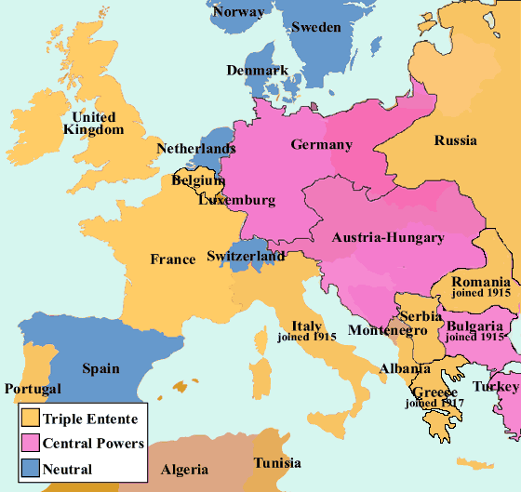
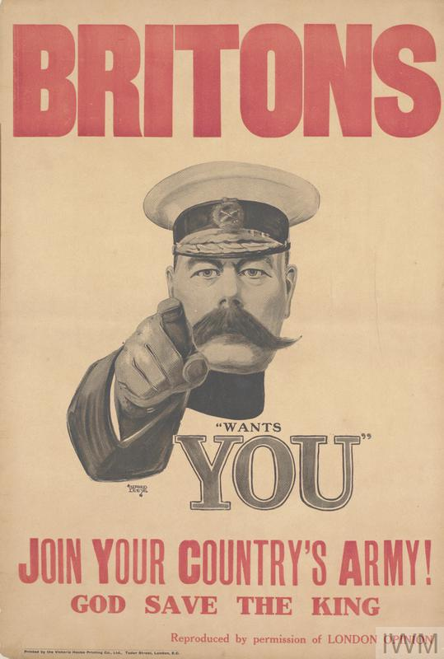

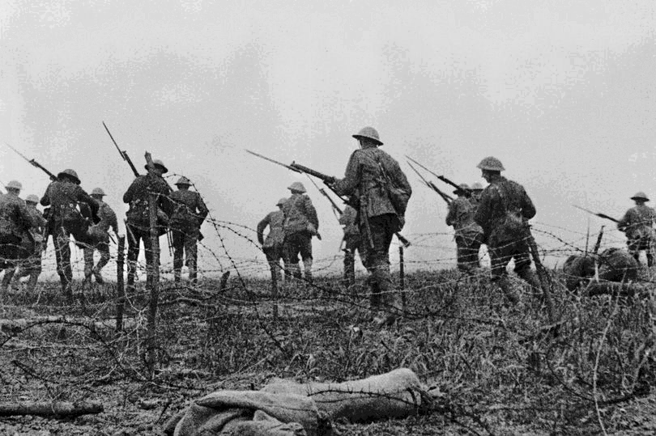

THINGS TO REMEMBER:

- The children will need to wear their PE kits to school on Mondays and Fridays.
- Homework will be issued on a Thursday and will be due on the following Tuesday.
- Reading records should be brought into school on a daily basis.
Websites:
https://www.ttrockstars.com/
https://www.mymaths.co.uk/
https://www.spellingshed.com/en-us

