GORSLEY GOFFS PRIMARY SCHOOL – MEDIUM TERM PLANNING
Y6 – MISS VOSS
National Curriculum
As Historians we will consider similarities and differences between ancient religions and different religions today. We will also establish a chronological context of the Maya and explore different sources of evidence about the Maya.

As Geographers we will be studying the physical features of Mexico and how they affect the human activity as well as the main physical and human characteristics of countries in North America. We will be exploring physical geography, including looking at topographic maps.

As Design Technologists we will design, make and evaluate a model of a Maya temple. We will also use clay to recreate Mayan art and artefacts. Furthermore, we will make create our own salsa to go with a tortilla recipe.

As Artists we will be studying Mayan art and artefacts. We will also explore the Bonampak murals and recreate a Mayan mask.

As Scientists we will be studying evolution and inheritance and identifying how characteristics are passed down from parent to child. We will study how natural selection and survival of the fittest leads to the evolution of species who have more advantageous characteristic for future survival.

In PE we will be developing methods to pass and defend in netball, and we will learn to recognise and suggest patterns of play which will increase chances of success. In gymnastics, we will develop our balance, travelling and jumps to create an imaginative sequence to perform to the class.

As Writers we will study myths and legends from the ancient Maya civilisation. They will then learn to use a variety of sentence types and we will look at a range of punctuation, which includes colons and semicolons. We will use the text ‘The Rain Player’ to write instructions for pok-a-tok, a missing scene, and a conduct debates. We will use the animated film Dia de los Muertos to find out about the Day of the Dead festival. We will write from the character’s point of view as well as completing a double page spread about the festival.

As Mathematicians we will be covering the following units:
- Know angle sums for pentagons, hexagons, and octagons, and use this fact to calculate missing angles;
- Illustrate and name parts of circles, including radius, diameter and circumference and know that the diameter is twice the radius;
- Calculate and interpret the mean as an average;
- Interpret and construct pie charts and use these to solve problems;
- Problem solving, reasoning and algebra
- Perimeter, area and volume

In French we will be learning the knowledge and skills to present both orally and in written form about where we live and which rooms we have and do not have in our homes in French. This is a unit that focuses on recycling previously learnt grammar, using it with new vocabulary, conjunctions and grammar, demonstrating a growing ability to create independent responses.

In RE we will consider what Christians believe Jesus did to save people. We will explore the events in Holy Week and consider the symbols used during this time.

In Music we be will exploring instruments particular to Mayan music including flute, pan pipe, whistles, rattles scrapers and drums and ocarina; pitched notation; rhythmical patterns; sounds and music inspired by rainforest leading to composition and score writing using some traditional notation. We will also be learning songs related to the Rainforest theme and create a class orchestra to accompany the song ‘Mexican Wave’.

In Drama, we will be considering how we treat people, looking at character development and learning about refugees in order to produce some role plays involving dialogue.

SPRING 2025 – The Ancient Maya Civilisation
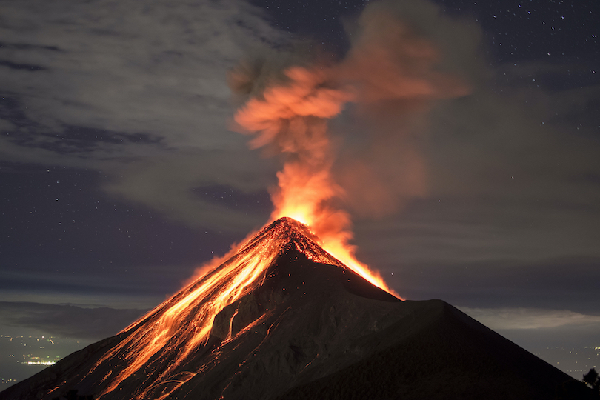
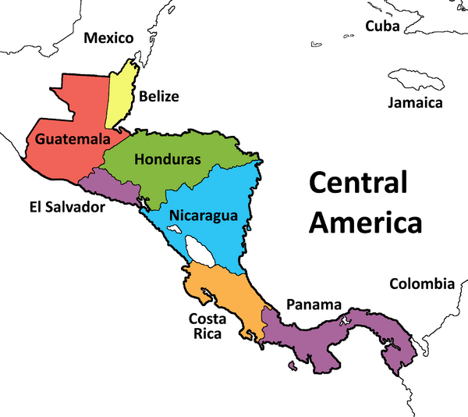
- PE will be on Mondays and Fridays.
- Homework will be issued on a Thursday and will be due on the following Tuesday.
- Reading records should be brought into school on a daily basis.
Websites:
https://www.ttrockstars.com/
https://www.mymaths.co.uk/

THINGS TO REMEMBER:

