GORSLEY GOFFS PRIMARY SCHOOL – MEDIUM TERM PLANNING
National Curriculum
In History we will be exploring the answers to the following questions: Who were the Ancient Greeks? What were the differences between Athens and Sparta? What was Ancient Greek warfare like? What did the Ancient Greeks believe? What was daily life like in ancient Greece? What impact did the ancient Greek civilization have on the world?

In Geography we will be exploring what Greece is like today as well as finding out about modern Greek culture.

In Design Technology we will be designing, making and evaluating a labyrinth. We will also be designing, creating and evaluating a reproduction of the Parthenon.

In Art we will be exploring examples of ancient Greek sculptures and murals. We will design make and evaluate an Ancient Greek mural.

In Science we will be finding out about the circulatory system. We will learn about blood and its function as well as how the heart works to pump the blood around the body.

In PE we will aim to develop our orienteering skills. We will also be taking part in a variety of track and field events in athletics.

In Drama we will begin rehearsing for our end of year production.

In Music we will learn and study the song ‘Go the Distance’ from ‘Hercules’. We will extend our compositional skills using the ‘12 Labours of Hercules’ as our inspiration; combining and extending our work on structure, instrumentation, melody, chords and scales. Will also focus on preparation for our year 6 production, learning songs, singing in parts and preparing for performance.

In English we will be writing texts to persuade and argue, using Greece as a stimulus. We will also be writing explanations to demonstrate our learning about the circulation and the heart. We will revise our knowledge of a range of SPAG such as how to use a semi-colon, colon and dash to mark the boundary between independent clauses [for example, It’s raining; I’m fed up].

In Mathematicians we will be covering the following units:
- Shapes and nets
- Math projects and puzzles

In RE we will consider how our faith can help us when things get hard.

In French we will learn how to say 10 Olympic sports as well as the 1st and 3rd person conjugations of the verb 'faire' in order to express which sports they do and do not do. They will also look at gendered nouns and the changes required when describing the Olympians in the unit.

In Computing we will design, write and debug programs that accomplish specific goals, including controlling or simulating physical systems and solving problems by decomposing them into smaller parts.
Y6 – MISS VOSS
SUMMER 2025 – Ancient Greece
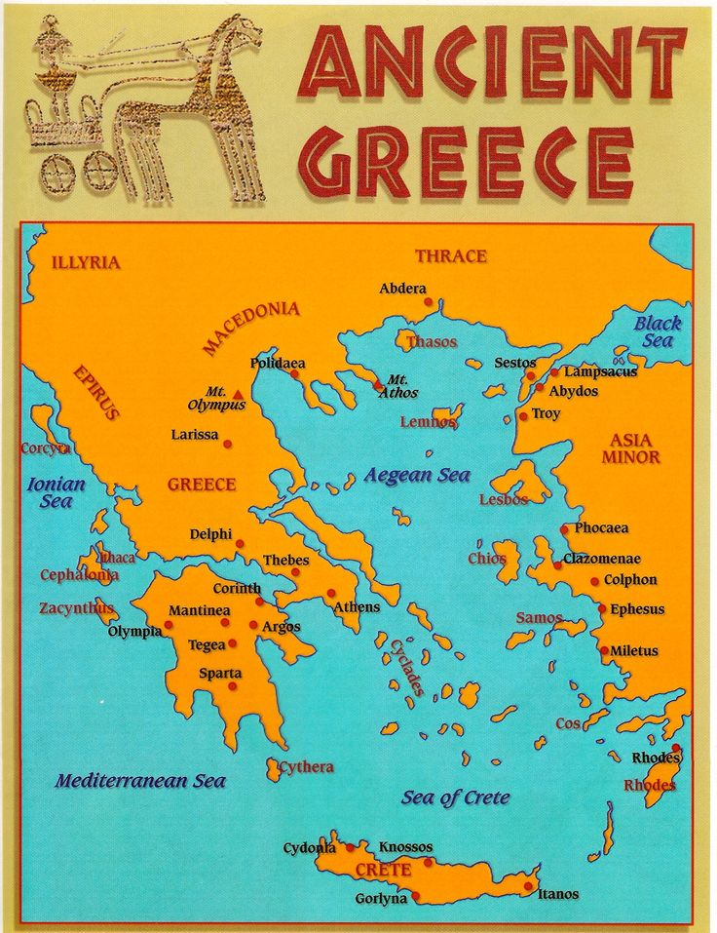
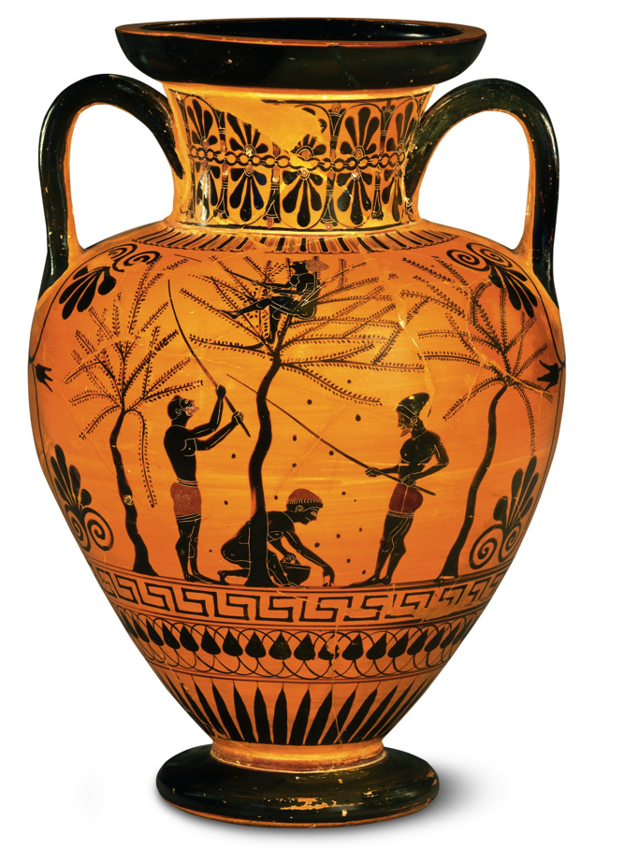
- The children need to read four times a week
- Homework will be issued on a Thursday and will be due on the following Tuesday.
- Reading records should be brought into school on a daily basis.
- PE will be on Mondays and Fridays.
Websites:
https://www.ttrockstars.com/
https://www.mymaths.co.uk/
https://www.edshed.com/en-gb/logout

THINGS TO REMEMBER:

