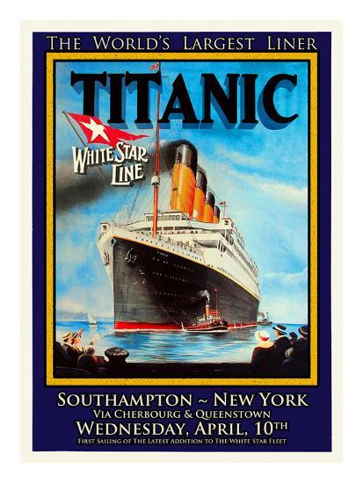

|  |  |  |
| --- | --- | --- |
| **DESIGN & TECHNOLOGY**  Design and make a model of RMS Titanic. You can use any type of material that you want for your model. | **ENGLISH**  Write a story, diary entry or poem about being a passenger on board Titanic’s maiden voyage. | **COOKING AND NUTRITION**  Find out about the food on board Titanic. You could even try cooking some of the menu at home. Don’t forget to bring in a photo if you do. |
| **HISTORY**  Research what else was going on in the world at the time the Titanic was built. What was life like for people? What was school like in 1912? Find out about money in 1912. What did coins/notes look like? | **HISTORY**  Research and then write about the differences in life between rich and poor passengers. | **ART & DESIGN**  Design a ticket to board RMS Titanic. Can you find out how much a ticket would have cost different classes of passenger? |
| **ART & DESIGN**  Design a costume for a 1st class lady or gentleman. | **HISTORY**  Make a timeline of the life of the Titanic. Add pictures or patterns to improve the presentation of your work. | **ENGLISH**  Write a newspaper report about the building of the mighty Titanic. |
| **SCIENCE & DESIGN**  Explore sinking and floating.  Design a life jacket using materials that would help someone stay afloat. | **MATHS & ART**  Find out the lengths of cruise liners today.  Create a poster showing the size of different cruise liners compared to the size of the Titanic. | **HISTORY**  Find out about the discovery of the Titanic wreck.  Find out if there have been any attempts to raise the Titanic. |

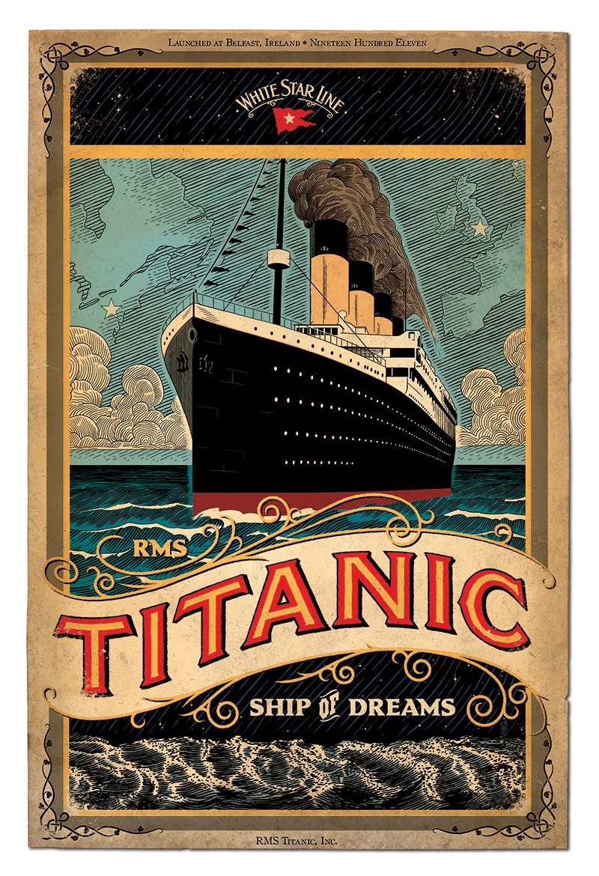**WYE CLASS HOMEWORK GRID: THE TITANIC**

**Complete one activity each week. Choose a variety of subjects from the homework grid.**

**If the children have completed their homework on a computer then please email me at wye@gorsleygoffs.hereford.sch.uk**