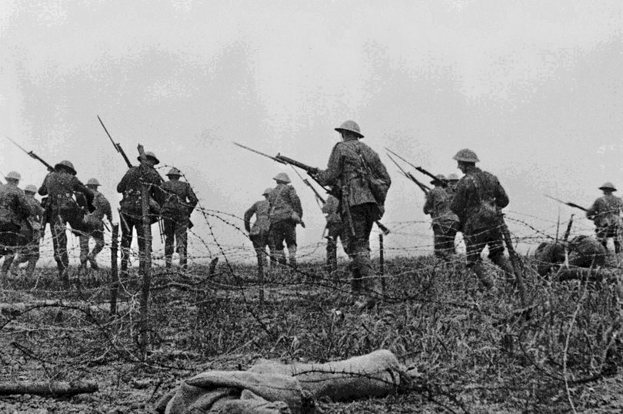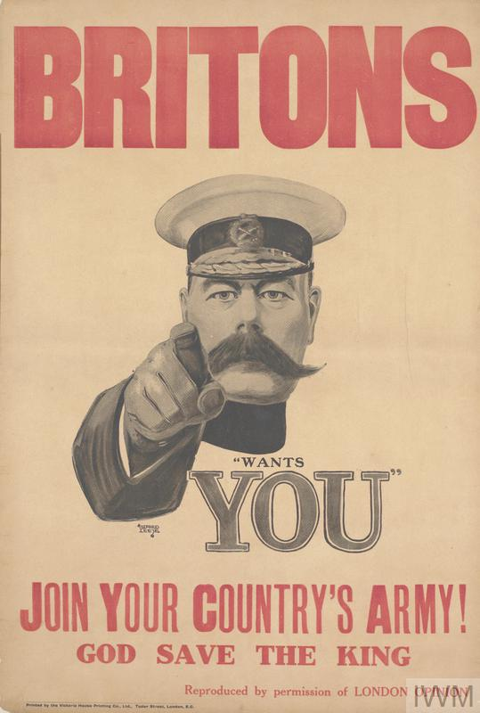**WYE CLASS HOMEWORK GRID: THE FIRST WORLD WAR**

**Complete one activity each week.**

**If the children have completed their homework on a computer then please email me at** [**wye@gorsleygoffs.hereford.sch.uk**](mailto:wye@gorsleygoffs.hereford.sch.uk)

|  |  |  |
| --- | --- | --- |
| Find out what the uniform of a First World War soldier was like. | Make a fact-file or interactive presentation on any of these important people:   * Douglas Haig * Walter Tull * Jack Cornwell * Edith Cavell * Helen Fairchild | Make an interactive presentation on the computer on a First World War topic that interests you. |
| Listen to a song written around the time of the First World War. Search for: ‘Pack Up Your Troubles’, ‘Keep the Home Fires Burning’ or Gustav Holst’s ‘The Planets Suite: Mars’ or ‘Jupiter’. Write down how you feel when listening to them. | Who was Sergeant Stubby and how did he help during the war? | Ask your family to help make a family tree. Can you find out which of your ancestors were alive during 1914 -1918? |
| Create your own poppies using recycled materials you have at home. For example, you could make one from the end of 2-litre bottle and paint the inside of the base red and black. | Find out what a war cake was and try making your own! | Propaganda  Google search “World War One Propaganda Posters”. Create an annotated poster, presentation or summary of your top three. |
| During the Christmas Truce, German soldiers reportedly sang Christmas carols. Find a German version of a famous carol and see if you recognise any words. | Research old currency used around the time of the First World War. | Measure out the ingredients and make a meal from a recipe from the early 1900s. Take photos. |