|  |  |  |
| --- | --- | --- |
| Listen to some Ancient Maya music on YouTube. Note down what instruments you can hear. | The Maya discovered chocolate. Cook something with chocolate in it or create a recipe with chocolate. | Tikal was one of the most powerful and influential cities in the Ancient Maya civilisation. Create a fact file about the city. |
| Research the Maya calendar and explain how it worked. | Research and create an information poster about the religious beliefs of the Maya and some of the Gods that they worshipped. | Write a Maya hero story, like the ancient myths they told.  <https://www.ducksters.com/history/maya/hero_twins_maya_mythology.php> |
| Draw 3 Mayan hieroglyphs and write down what they mean.  Challenge: can you write a Mayan sentence? | What were the Mayan warriors like? Can you draw a picture of one? Write about who they were and what weapons they had. | Where about in the world did the Mayan’s live? Use a map to find out! Can you plot the different Mayan cities on the map? |
| The Maya loved chocolate.  Think about your favourite chocolate treat? Design a wrapper for a new chocolate bar you have invented. | Can you find out about the Maya Number System? Make your own maths calculation using the Mayan number system. | Can you design and create your own Maya headdress? Take a photo of you wearing it and write a paragraph about why they wore them. |

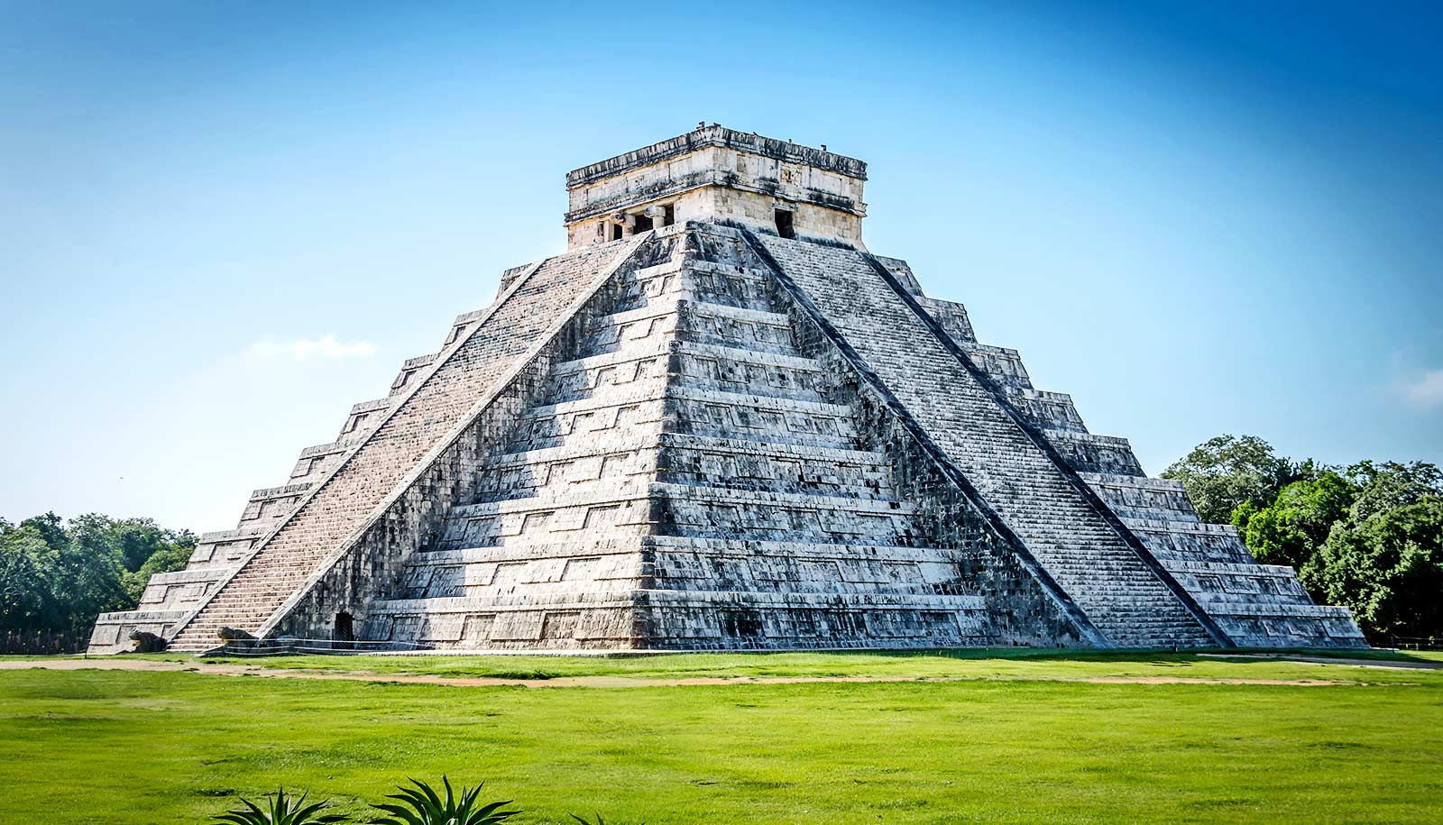**WYE CLASS HOMEWORK GRID: THE ANCIENT MAYA CIVILISATION**

**Complete one activity each week.**

**If the children have completed their homework on a computer then please email me at wye@**

**gorsleygoffs.hereford.sch.uk**