|  |  |  |
| --- | --- | --- |
| Make an A-Z of Greece. Think about presenting your work in the best way possible. What could you do on the border? You could add an illustration to each or some of the letters along with small pictures linked to your sentences. | Who was Pythagoras? How is he linked to maths? What is Pythagoras’ theory? Present your findings – use diagrams to explain what you have learnt. | Find out about the Greek alphabet and present your findings in an exciting way. |
| Create a picture of an imaginary Greek God. Make sure your poster is eye-catching and full of facts and information. Try to think of a symbol for your God. | Make a Spartan helmet or design a shield. | Find out what life was like for children in Ancient Greece. How will you present your information? |
| Find out some simple Greek phrases. E.g. Hello, How are you? What’s your name? Etc. Can you make a poster to display them in Greek & English? Make sure you can pronounce them correctly and teach them to the class! | Make a list of 20 words that we use today that are based on Greek words – along with their meanings | Write an advert persuading people to visit the ancient Olympic Games. |
| Write a newspaper article detailing the events surrounding the Trojan horse | Make an abacus and write an explanation of how it works. | Cook some Greek food or a meal. Write up the recipes. Can you include a photo of your creation too? |

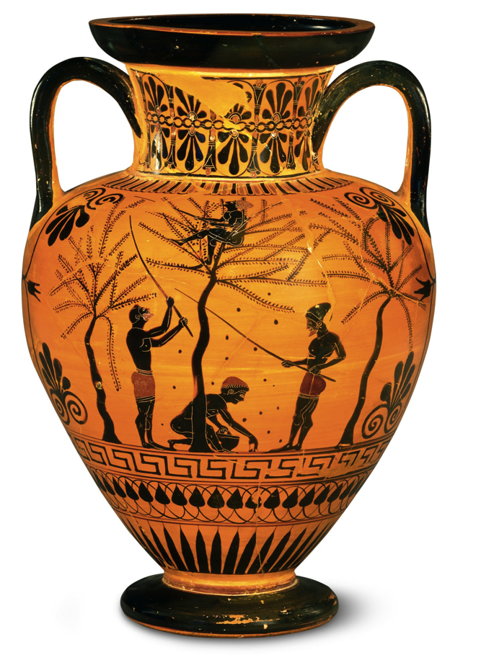**WYE CLASS HOMEWORK GRID: ANCIENT GREECE**

**Complete one activity each week.**

**If the children have completed their homework on a computer then please email me at wyehomework@gorsleygoffs.hereford.sch.uk**