# Welcome to Wye Class

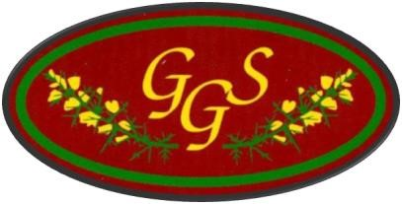

Year 6 2024-2025

Wye Class Staff

* Miss Voss
* Mrs Hargreaves
* Mrs Dyer

# Aims of Year 6

* To consolidate skills and knowledge.
* To identify gaps/areas which need further work.
* For each child to achieve his or her full potential.
* For each child to be given the relevant opportunities and skills to fulfil their potential and prepare them for the challenges ahead.
* For a successful transition from Year 6 to secondary school.
* For all children to have the learning tools to progress further in their education.
* The children **must** have their reading record with them on a daily basis.
* Playtimes – Healthy snacks, drink. **Water** bottle for the classroom.
* Lunchtime – drink for lunch please.
* PE days – Currently Monday (outdoor) and Friday (indoor). Please ensure your child wears their P.E kit in school on both days.

# Behaviour expectations

* 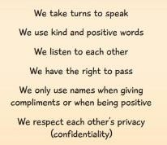Class charter
* House points awarded for the children’s classwork as well as showing acts of kindness such as holding the door open for others.
* Celebrating Champions certificates
* Focus on being ready, respectful and safe.

## TIMETABLE

# The key skills of progression

* An overriding topic for each term which covers the progression of key skills addressed in the National Curriculum.
* Cross-Curricular links within the topic to cover the foundation subjects such as DT, Art, Computing, History and Geography.
* Autumn 1 – The Titanic
* Autumn 2 – The First World War
* Spring 1 – Extreme Earth: Volcanoes and Earthquakes
* Spring 2 – The Ancient Maya Civilisation
* Summer – Ancient Greece

# Homework

Every week:

* Reading (at least 4 times a week)
* Spelling list on Spelling Shed
* Maths or English task
* Complete a task each week from the topic homework grid. Please encourage your child to choose a variety of subjects from the grid.
* It’s really important they understand their homework and if they don’t, even with support, then they MUST come and see me.
* Homework will be set on Thursday and due in on Tuesday.

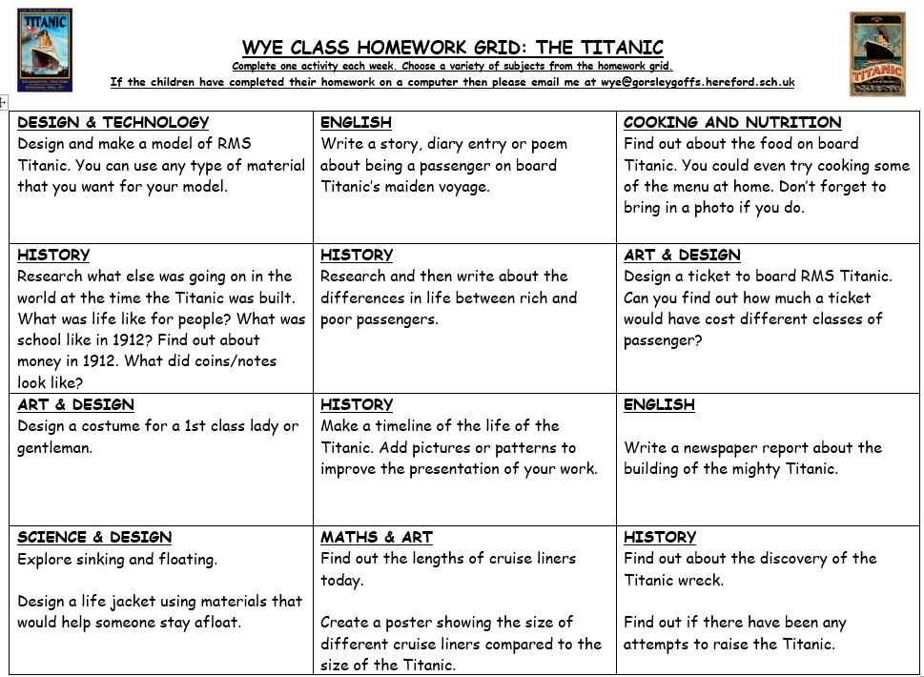

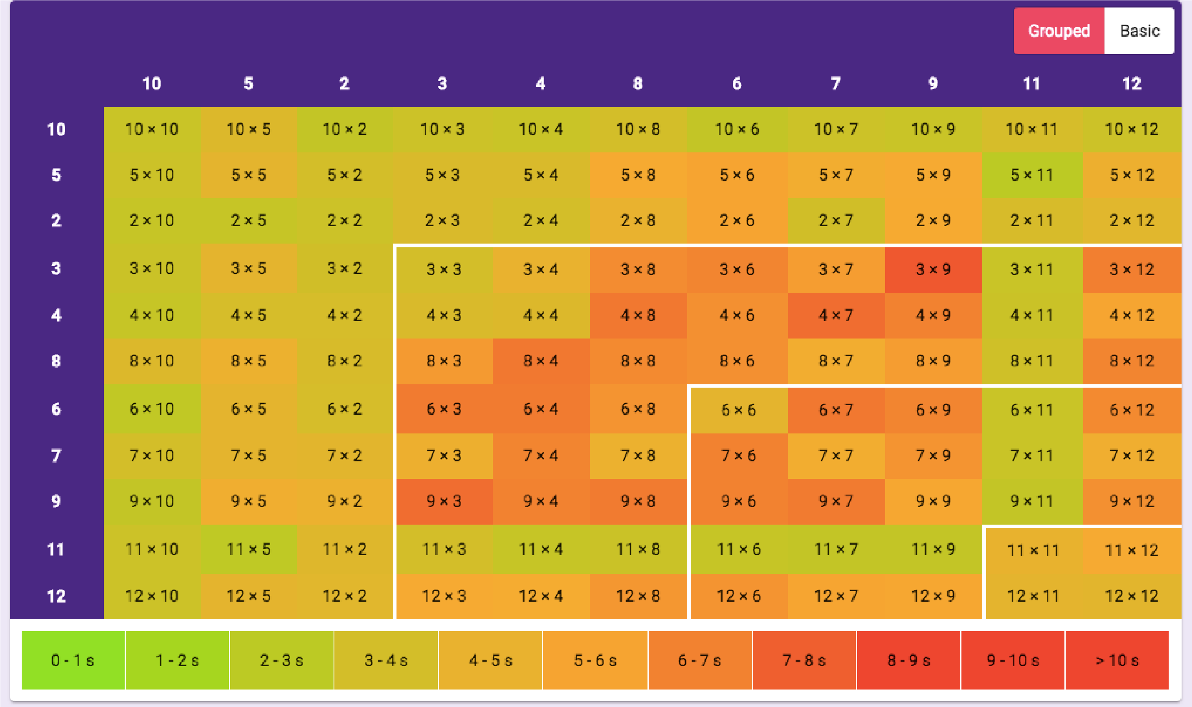

Regular practise of

multiplication and division

facts will help the children

to develop fluency when

answering arithmetic

questions.

Please encourage your Reading child to read at least 4 times a week and record in their reading record.

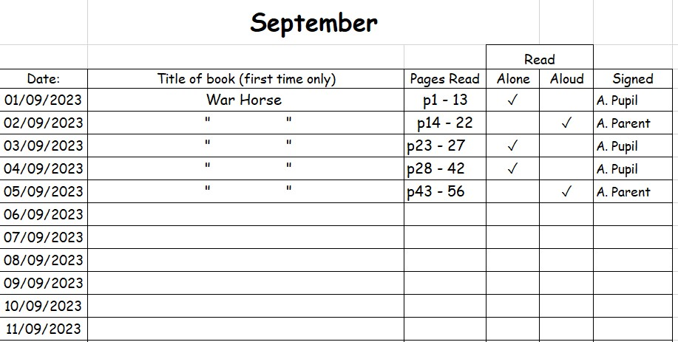

# Spellings

* Focus on a spelling pattern/group of words.
* Spelling test: Friday
* Highlighted in class work.
* The children will need to learn the Year 5 and 6 statutory words. They will be available on Spelling Shed and on the class page of the school website. A list of these words can be found on the next slide.

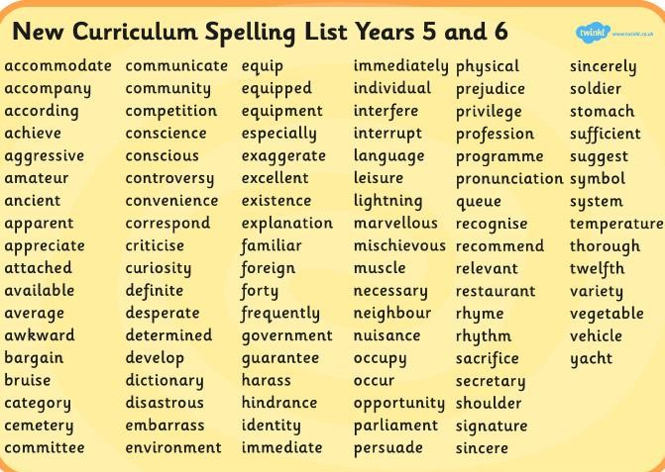

# Grammar, Punctuation and Spelling

This Jargon Buster is available to download on the class page of the school website. This will help your child learn the

definitions of

some

challenging grammatical vocabulary.

Key Stage 2 National Curriculum Tests – Monday 12th May to Thursday 15th May 2025

* Consolidation of skills and knowledge throughout the year to prepare them for the tests.
* Revision will take place nearer the time.
* Maths – Paper 1 Mental Arithmetic Papers 2 and 3 Reasoning.
* Reading
* GPS – Grammar, Punctuation and Spelling
* More information to follow at a later date.

# London 2025

* Monday 2nd June to Friday 6th June

2025

* More information about the residential will be sent out in due course.



How can you help?

* Reading: Discuss the text which is being read and develop inference and deduction skills by ‘reading between the lines’. Reading 20 minutes a day can have a significant impact on your child’s achievement.
* Times tables: These are extremely important as they support a range of areas in maths. The children need to be confident in these so practise is key.
* Spelling: Please support your child in learning the Year 5 / 6 words. It will also help to put these words into context by including them in a sentence.