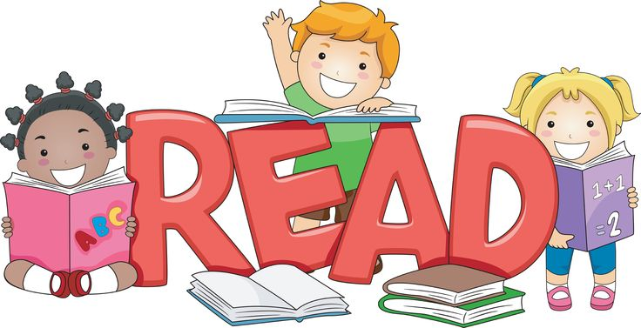
Reading in Acorn Class

Our primary aim is to teach the children the phonetic skills they require to be able to blend words fluently with the expectation that they will develop as fluent readers as they progress through the school.
We follow a programme produced and recommended by the Government called Letters and Sounds as the basis for our phonics teaching and this synthetic phonics programme is taught systematically throughout the Foundation Stage and Key Stage One.
Every day we teach a 20 minute phonics session, endeavouring to make the sessions fun and interactive for the children using a range of stimulating resources and approaches. The children will bring home evidence of sounds we have learned at school and their accompanying actions, so that they can be practised at home too.
Phonic knowledge and skills are regularly monitored and assessed to ensure rapid and sustained progress.

At the start of the school year, children in Acorn Class will choose picture story books to bring home. I have attached Jeremy Strong’s “Reading Tips for Parents” as he emphasises the importance of this far more eloquently than I ever could! Your child will be given a reading record in which you are encouraged to write down what books have been shared and how your child responded to them.

Once basic phonetic skills are established within the class, we start to look at “tricky” words ~ words that simply cannot be sounded out (such as “the”). When I feel that the class are ready, children will begin to bring reading scheme books home. It is hoped that you will hear your child read regularly at home (at least three times a week) for a 5-10 minute period (short and often is definitely the best way to go!).

“To learn to read is to light a fire; every syllable that is spelled out is a spark.”
Victor Hugo

Happy Reading!
I Harris

