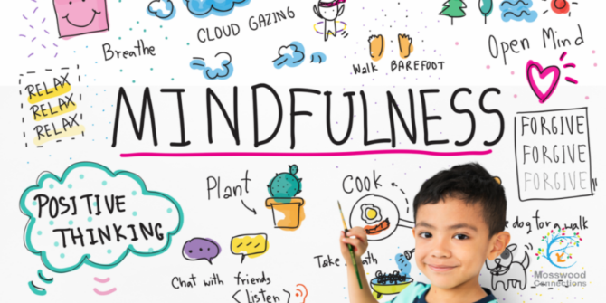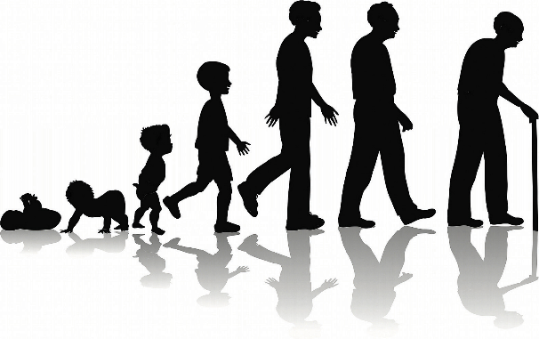x

Inline with our class novel, Room 13, write a nightmare sequence. Conclude it with the character waking up and not knowing whether it was a dream or not…

Underline every time you use figurative language.

Date:­­­­_______________________

Create a poster to promote positivity in the classroom.

Date:­­­­______________________

Keep a mindfulness diary for one week. Write down 3 things you are grateful for each day.

Date:­­­­_____________________

Write a poem about being human. You can choose the style, but be sure to include how it feels to be human.

Date:­­­­_____________________

Investigate whether male babies are heavier than females. Gather as much data as you can from family and friends and present your findings in a table. Be sure to include your prediction and a conclusion.

Date:­­­­_____________________­­­­_____

Homework due in on Wednesday.

To do:

* One topic activity.
* MyMaths tasks as set.
* Revise times tables.
* Spellings.
* Reading.

Create a self-portrait. Use any medium you like – be creative! Will you choose realism or abstract?

Date:­­­­_____________________

Create a comic strip to show the stages of human development.

Date:­­­­_________________________

Using everything you learnt about vector drawing in our computing lessons. Create a vector drawing of a famous person who has influenced you.

Date:­­­­_________________­­­­­_____­__­­­__

Summer 2

‘Being Human’