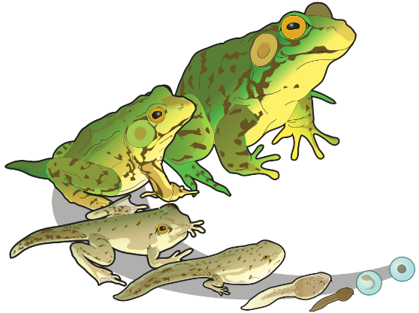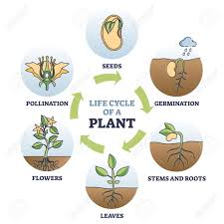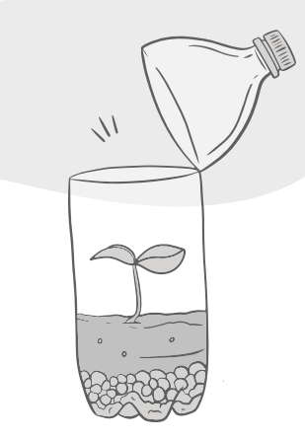x

Over two weeks create a double page spread. Choose a country and research the climate, time zones, longitude and latitude coordinates, biomes, native wildlife and plant life. Be creative with your presentation.

Date:­­­­_____________________

Research the mammal that lays eggs. Present your findings in an interesting way.

Date:­­­­_____________________

Create a biome in a bottle. Use an empty plastic bottle and carefully cut in half (ask an adult to help), add a layer of gravel and compost then add a plant or two (weeds are fine!). Water the plants then tightly tape the top half of the bottle back on. Place in a sunny windowsill and watch your biome thrive! Keep a diary of what you notice.

Date:­­­­_____________________­______________

Design a poster for either an aquatic, grassland, forest, desert, or tundra biome. Include the climate, wildlife and vegetation that can be found there. Date:­­­­_________________­­­­­_____­__­­­__

Write a non-chronological report about animals that go through metamorphosis. Remember to include subheadings.

Date:­­­­__________________________

Create a flip book of a flowering plants life cycle. Label the diagrams correctly.

Date:­­­­______________________

Summer 1

‘Circle of Life’

Choose your favourite mammal and write a recount of their life cycle, start from an embryo and end as an adult. Add some photographs (drawings) of each stage.

Date:­­­­_______________________

Homework due in on Tuesday.

To do:

* One topic activity.
* MyMaths tasks as set.
* Revise times tables.
* Spellings daily.
* Reading 5x a week.