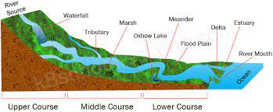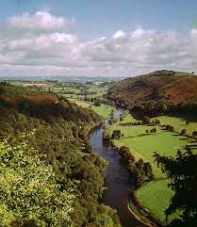x

Write a recount of the last time you were near a river, what could you see, smell, touch, hear?

Date:­­­­______________________

Spring 2

‘Water Matter’

Make a collage of a river, be creative with your materials. Use pens, pencils, recycling waste and nature (check with a grown up before cutting anything!)

Date:­­­­_____________________

Design a poster to help someone learn about the upper, middle and lower course of a river.

Date:­­­­_____________________

Create a fact file based on a river animal of your choice.

Date:­­­­_____________________­__

Interview a grown up you know about the most important river in their life and why.

Date:­­­­_________________­­­­­_______

Write a poem about how a river changes as it moves downstream. Think about your presentation, can you represent the river in your presentation?

Date:­­­­________________________

Observe a puddle over time (or create your own if it’s dry!) Use chalk to draw around the edge and check on it after 1, 2 and 3 hours. What do you notice? Record your findings.

Date:­­­­_______________________

Homework due in on Tuesday.

To do:

* One topic activity.
* MyMaths tasks as set.
* Revise times tables.
* Spellings daily.
* Reading 5x a week.