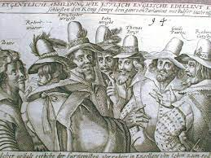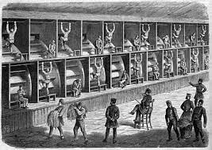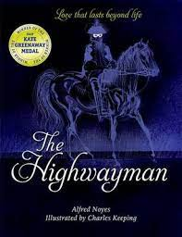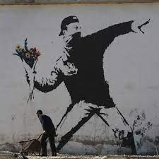s

History

We will be studying ‘Crime and Punishment’ throughout the ages of British history, starting with the Romans and ending in the 21st Century. We will interview a police officer, asking our own thought-provoking questions.

We will be looking at key

trends over time with

common crimes and exploring

how detection has changed.

PSHE and RE

Our PSHE lessons will focus on our ‘Goals and Dreams’ and how these may change.

In RE we will be considering ‘What matters most to Humanists and Christians?’

Art

We will continue our theme of ‘crime’ by discovering the works of Banksy and Keith Haring. Is graffiti and street art a crime?

We will explore different techniques used by these artists in order to create our own final pieces using a combination of these.

PE

Indoor – Real Gym

Outdoor – Netball

Computing

Explore the concept of selection in programming through the use of Lego WeDo.

Music and Drama

As musicians we will be learning about different sections of the orchestra, particularly focusing on strings and percussion and create a class orchestra.

In Drama we will be exploring poetry.

Science

As scientists we will be exploring different materials and their properties. Through a series of investigations, we will discover how some materials dissolve in liquid to form a solution and learn how to reverse this where possible. We will base our lessons around our topic and try to escape from prison!

English

To begin this half term, we will be studying Alfred Noyes ‘The Highwayman’ to explore character descriptions. We will then look at poetry through Brian Bilston’s ‘Refugees’ and create our own palindromes as well as discovering Elizabeth Fry and writing a modern-day speech in favour of prison reform.

Spellings will be changed weekly with a quiz every Friday.

Maths

This half term we will continue with multiplication and division by looking at multiplying and dividing a 4-digit number by 1- or 2-digit numbers. We will then revisit fractions further by exploring multiplying and dividing them by whole numbers. Then finishing with decimals and percentages, comparing, ordering rounding and understanding thousandths in relation to tenths and hundredths as well as recognising the per cent symbol (%) and writing percentages as a fraction.

Spring 1

‘Crime and Punishment’

Modern Foreign Languages

In French we will be learning how to say the date.