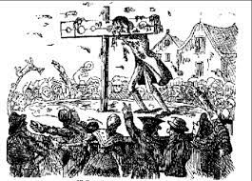x

Spring 1

‘Crime and Punishment’

Design a wanted poster, who are they and what crime have they committed?

Date:­­­­_________________

Listen to the News or read a Newspaper, make notes on any crimes you find and how the criminal was punished.

Date:­­­­_________________

Write a diary entry from the point of view of an escaped convict, how would they be feeling? What crime have they committed? Are they guilty?

Date:­­­­_________________

Using an old boot as a portal key, write a short story where you are transported to the scene of a crime. Describe the setting using as much detail as possible.

Date:­­­­_________________

Create a ‘spot the difference’ picture of a medieval trial and a modern one. How many differences are there to find?

Date:­­­­_________________

Design and create your own police uniform, what features would you include? Label your design.

Date:­­­­_________________

From your learning in class, create a 3D model of a historic punishment using materials you can find e.g. sticks or toy bricks.

Date:­­­­_________________

You and your friends have just discovered a new country, make a set of laws to keep your citizens safe.

Date:­­­­_________________

Homework due in on Tuesday.

To do:

* One topic activity.
* MyMaths tasks as set.
* Revise times tables.
* Spellings daily.
* Reading 5x a week.