Help and support for Families

We recognise that at times families may need some extra help, signposting or support, often this can be from friends, family or someone in the community but sometimes more may be required. Below are some of the places you might be able to find out more about the right support for your child and family.

Children’s Help and Advice Team (CHAT).
CHAT
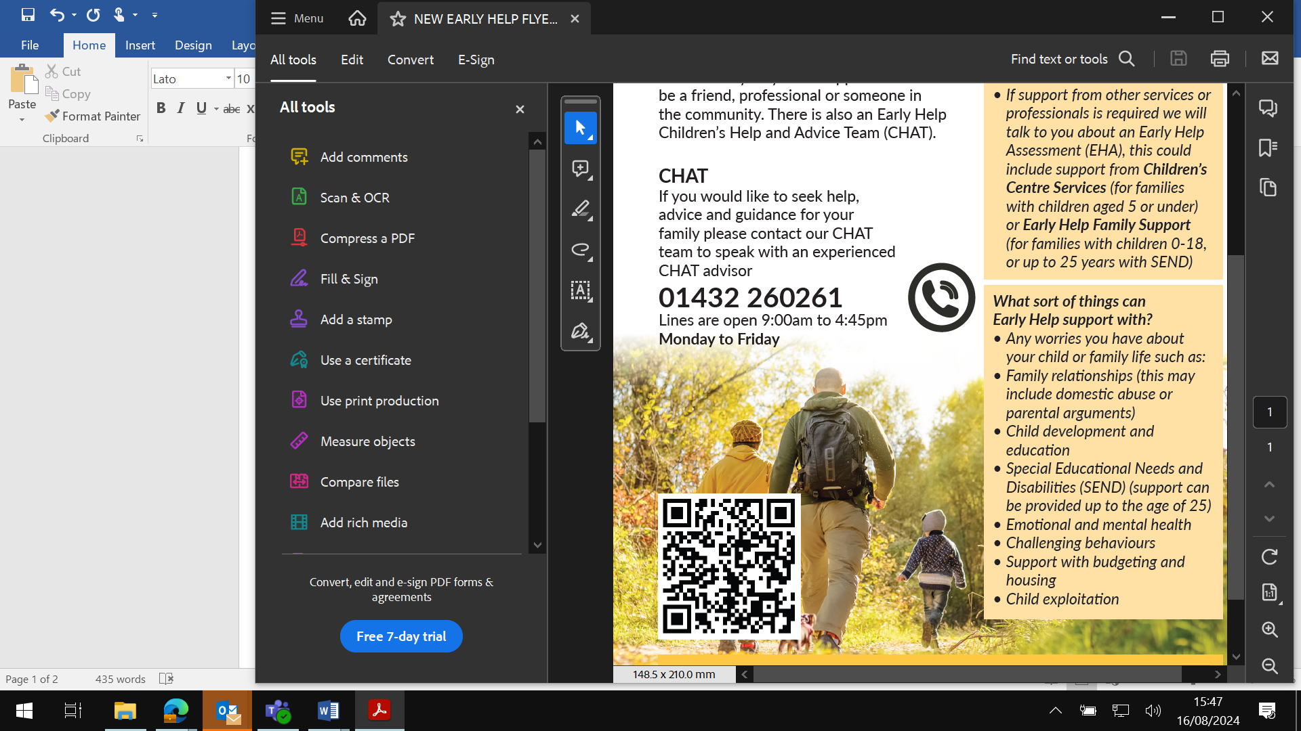

Often families can solve their own problems, at times they may need support. If you need any advice or support for your child or your family, we recommend you share your worry with a professional you feel comfortable talking to or call CHAT (Children’s Help and Advice Team within Early Help) if that works better for you and speak to an advisor.

A CHAT advisor can give advice over the phone, send you out information and signposting, or if needed, arrange a package of support through an Early Help Assessment to access a family support worker if required. This could include support from Children’s Centre Services (for families with children aged 5 or under) or Early Help Family Support (for families with children 0-18, or up to 25 years with SEND)

We have information on a wide range of needs
Parenting support
Bullying
Family relationships
Online safety
Attendance
Behaviour worries
Mental health
Finances
And more

If you would like to seek help, advice and guidance for your family please contact our CHAT team to speak with an experienced CHAT advisor
01432 260261
Lines are open 9:00am to 4:30pm Monday to Friday

Further links to direct support for children and families

Additional support for SEND – link to local offer and short breaks
- Herefordshire SEND local offer Local offer special educational needs and disabilities – Herefordshire Council
- Sendiass Hereford / Worcester Welcome to SENDIASS Herefordshire and Worcestershire | Worcestershire County Council
- Herefordshire Short Breaks Scheme Short Breaks Scheme – Herefordshire Council

Wellbeing and Mental Health – Children
- CAMHS Herefordshire & Worcestershire Herefordshire Child and Adolescent Mental Health Services | Herefordshire and Worcestershire CAMHS (hacw.nhs.uk)
- CLD Trust WELCOME | The CLD Trust
- Kooth Home - Kooth

Wellbeing and Mental Health – Adults
- Healthy Minds – Now We’re talking Welcome to NHS Talking Therapies | Talking Therapies (hwhct.nhs.uk)
- Herefordshire Mind Herefordshire Mind - Herefordshire's Local Mental Health Charity (herefordshire-mind.org.uk)
- The Cartshed Woodland wellbeing Herefordshire | The Cart Shed | England

Other support
- Turning Point Herefordshire Recovery Service | Turning Point (turning-point.co.uk)
- Women’s Aid West Mercia Women's Aid | WMWA is a full member of the Women’s Aid Federation of England. (westmerciawomensaid.org)
- WRASAC Home - WMRSASC
- Herefordshire Directory of Early Help Herefordshire Directory of Early Help Services
- Virtual Family Hub – TC Directory – Virtual Family Hub - Talk Community Directory
- Parenting Courses Parenting groups and courses – Herefordshire Council

