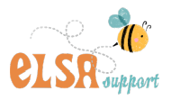
We are pleased to be able to share information with parents about our Emotional Literacy Support Assistants on this website. On this page we aim to post ideas and helpful advice on how you can help your child; for example in areas such as empathy, self esteem or perhaps to pick up some tips about calming techniques. Parents and carers will be able to find out about recommended books which may be useful and links to other websites for some self-help at home

What is ELSA?

There will always be children and young people in schools facing life challenges that detract from their ability to engage with learning. Some will require greater support to increase their emotional literacy than others. ELSA is an initiative developed and supported by educational psychologists. It recognises that children learn better and are happier in school if their emotional needs are also addressed.

The majority of ELSA work is delivered on an individual basis at Gorsley Goffs, but sometimes small group work is more appropriate, especially in the areas of social and friendship skills. Sessions are fun, we use a range of activities such as: games, role-play or therapeutic activities such as mindfulness or arts and craft. ELSA sessions take place in the school ‘Snug’ which provides a calm, safe space for the child to feel supported and nurtured.

In ELSA we aim to provide support for a wide range of emotional needs:

Recognising emotions
Anxiety
Self-esteem
Social skills
Friendship skills
Anger management
Loss and bereavement

Download: ELSA Leaflet PDF

ELSA activities for you and your child - please see the links and documents below.
Click on the links below to see the activities
Self-esteem
Feelings and emotions
Worries and Anxiety
Wellbeing and Mindfulness
Friendships and Relationships

How does ELSA work?
Children are usually referred for ELSA support by their class teacher, Senior Leaders or on occasion the SENDCo. Every half term the ELSA team (Ms. Brown and Mrs Hargreaves) meet with the SENDCo, to discuss the referral forms and to identify and prioritise which children require a weekly programme for the next 6 weeks. With the programme aims in mind the ELSA team plan support sessions to facilitate the pupil in developing new skills and coping strategies that allow them to manage social and emotional demands more effectively. If your child requires ELSA sessions then a letter will be sent out from the SENDCo.

Supporting - not fixing
Remember, ELSAs are not there to fix children's problems. What we can do is provide emotional support.
We aim to establish a warm, respectful relationship with a pupil and to provide a reflective space where they are able to share honestly their thoughts and feelings.
It needs to be appreciated that change cannot necessarily be achieved rapidly and is dependent upon the context and complexity of the presenting issues. For children with complex or long-term needs it is unrealistic to expect ELSA intervention to resolve all their difficulties, however support will be designed to target specific aspects of a child's need. Training and development of ELSAs is an ongoing process and wisdom is required to recognise when issues are beyond the level of expertise that could reasonably be expected of an ELSA. In these cases, school supports parents with referrals for specialist counselling or to CAMHS.

What do the children think ?
On completion of the ELSA programmes we ask the children to reflect on their experiences and to kindly give some feedback.

Completion of ELSA
On completion of the ELSA programme with your child, a brief ELSA report will be sent out to parents to feedback on the sessions with some tips for parents to support children at home. This information will be passed to their class teacher and SENDCo who will decide if another referral is required or if a referral needs to made to external outside agencies.

Parent feedback
On completion of the ELSA programme, parents will be asked for feedback. We will send your child home with a feedback form for your comments on whether or not the intervention has been of benefit to your child.
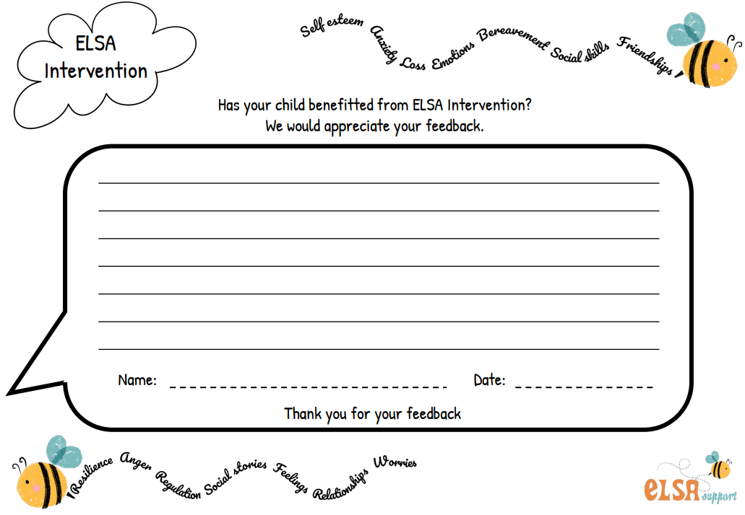
Parents Self-Help Section
Here are links to different websites online and some of the books in our ELSA library, which we are more than happy to loan out.

Do you have an anxious child?
Follow the link below for some useful guidance on helping your child overcome anxieties:

https://copingskillsforkids.com/calming-anxiety

Self esteem
Is your child having problems with self esteem? Try following this link which gives some useful advice to parents:

http://www.familylives.org.uk/advice/primary/health-and-development/helping-your-child-build-self-esteem/

Parental advice on anger management
Help with those 'hot feelings' - some tips and information for parents/guardians about managing anger in children:
http://www.scholastic.com/parents/resources/article/praise-discipline/anger-management-children

Books that we can loan out to parents:
‘All About Feelings’ by Felicity Brooks and Frankie Allen

‘Sadsville’ by Martin Roberts

‘Muddles, Puddles and Sunshine’ by Diana Crossley

‘When someone very special dies’ by Marge Heegaard

‘The Huge Bag of Worries’ by Virginia Ironside

Sad Book by Michael Rosen

Stay Strong by Dr Sharie Coombes
Sleep Tight
Be Resilient
Be Brave

The Worry Workbook by Imogen Harrison

