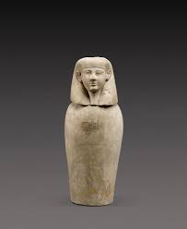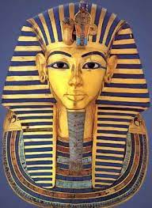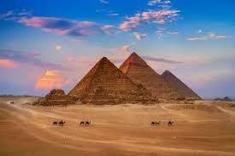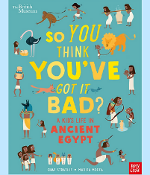

Maths

As Mathematicians we will be continuing our topic of multiplication and division, learning about prime numbers, square and cube numbers as well as multiplying and dividing by 10. 100 and 1,000.

We will then move on to our first fractions unit where we will learn how to find equivalent fractions before comparing and ordering fractions as well converting fractions from improper to mixed number. We will end the unit by adding and subtracting fractions.

Autumn 1

‘Walk like an Egyptian’

Art

As Artists this half term we will be exploring Ancient Egyptian artwork, focusing on the depiction of Pharaohs. We will create our own papyrus to use in our final piece where we will explore the work of modern-day artists Gerhard Richter and Valeria Trasatti to create self portraits of ourselves as Pharaohs. We will also make our own cartouche.

PE

Indoor - Dance

Outdoor – Hockey

Science

As Scientists we will be looking at forces with our key scientist this half term being Sir Isaac Newton. We will look at gravity, air resistance, friction and water resistance through a series of investigations. We will end our topic by exploring how some mechanisms can allow a smaller force to have a greater effect and create shadufs.

Computing

We will learn how to use different drawing tools to help us create images. By recognising that images in vector drawings are created using shapes and lines, we will layer objects and begin grouping and duplicating them to support the creation of more complex pieces of work.

PSHE and RE

Our PSHE lessons will focus on ‘Celebrating differences’ this half term.

In RE we will be exploring the question ‘Why do Christians believe Jesus was the Messiah?’

English

As Writers we will begin by looking at setting descriptions based on a portal story. We will revisit instruction writing when looking at the mummification process and use our experience of discovering Tutankhamun’s tomb during our Egyptian Extravaganza to write a newspaper article.

Spellings will be changed weekly with a quiz every Friday.

Music and Drama

As Musicians we will be creating and performing class and group compositions, the purpose for compositions will be ‘an Egyptian ceremonial piece’, using untuned and ultimately tuned percussion.

As Dramatists this term we will be story telling through role play and taking part in pair and group improvisations.

History/Geography

We will begin our topic by using

atlases to research and locate

Egypt.

We will create a timeline of

ancient Egypt and use text books to add additional information.

We will discover why the river Nile was and remains so important to Egypt. We will research what life was like in ancient Egypt across society.

Modern Foreign Languages

As linguists we in French we will be learning about the weather.