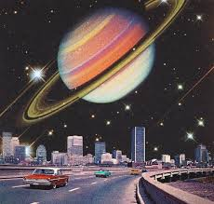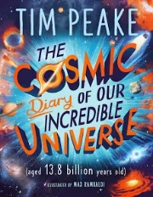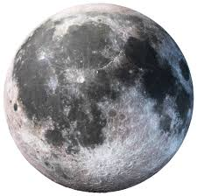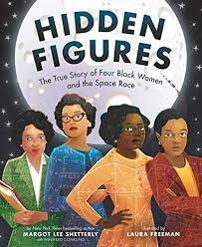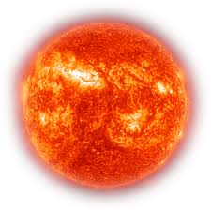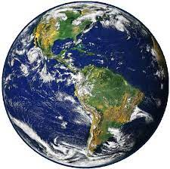

DT

We will produce a moving toy to show how a planet rotates on its own axis through the use of a cam and follower.

PE

Indoor – Gymnastics (Monday).

Outdoor – Tag Rugby (Friday).

Maths

We will be building on our Place Value knowledge at the start of Year 5. Firstly, looking at Roman Numerals up to 1000 then numbers within 1,000,000. We will be ordering, comparing and rounding numbers following the White Rose Maths scheme.

We will then explore addition and subtraction with more than 4 digits, inverse operations and missing number problems to strengthen understanding.

PSHE and RE

Our PSHE lessons will focus on ‘Being me in my world’.

In RE we will be exploring the question ‘What does it mean if God is holy and loving?’.

History

As Historians we will learn about

the Space Race and find out about Cecilia Payne-Gaposhkin. We will focus on interpretation, chronological understanding and communication to develop our enquiry skills.

Music and Drama

Using Holst's 'Planet Suite' we will explore different art forms as a creative response. We will use untuned and tuned sound, including iPad technology.

In drama we will use ‘The Last Bear’ novel to explore the effects of climate change on Earth.

Computing

We will develop our understanding of computer systems and how information is transferred between systems and devices.

Science

As Scientists we will learn about the movement of Earth and other planets relative to the Sun by understanding their order and how they move. We will look at the Earth’s rotation to explain day and night.

Autumn 1

‘To infinity and beyond!’

English

This half term we will be exploring non-chronological reports, diary entries and persuasive writing in the form of a travel leaflet. Using our topic for inspiration we will be developing our skills of writing to

inform and persuade.

Spellings will be changed weekly

with a quiz every Friday.

Modern Foreign Languages

In French we will be learning about the planets.