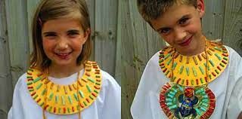
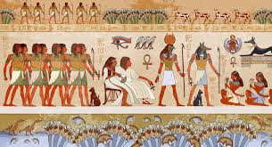
Create your own Egyptian God and write a character description about them.
Date:_________________
After working as part of an excavation team, you uncover precious Egyptian artefacts. Write a diary entry about your day.
Date:_________________
Research an ancient Egyptian God of your choice and create a ‘Top Trumps’ card for them.
Date:_________________
Design and create your own ancient Egyptian jewellery and/or headpiece. Get creative!
Date:_________________
Design a poster with your name in hieroglyphics.
Date:_________________
Create a persuasive leaflet to encourage people to visit Egypt, what things should they visit?
Date:_________________
Homework due in on Wednesdays.
To do:
- One topic activity.
- MyMaths set tasks.
- Spellings.
- Reading.
You have discovered a hidden tomb! Draw a map and write a set of instructions to guide you through – avoid the traps!
Date:_________________
Autumn 2
‘Walk like an Egyptian’
Using the words ‘ancient Egypt’ write an acrostic poem.
Date:_________________

