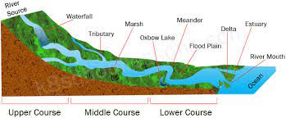
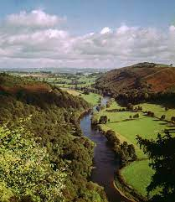
x
Write a recount of the last time you were near a river, what could you see, smell, touch, hear?
Date:______________________
Spring 2
‘Raging Rivers’

Make a collage of a river, be creative with your materials. Use pens, pencils, recycling waste and nature (check with a grown up before cutting anything!)
Date:_____________________
Design a poster to help someone learn about the upper, middle and lower course of a river.
Date:_____________________
Create a fact file based on a river animal of your choice.
Date:_______________________
Interview a grown up you know about the most important river in their life and why.
Date:________________________
Write a poem about how a river changes as it moves downstream. Think about your presentation, can you represent the river in your presentation?
Date:________________________
Observe a puddle over time (or create your own if it’s dry!) Use chalk to draw around the edge and check on it after 1, 2 and 3 hours. What do you notice? Record your findings.
Date:_______________________
Homework due in on Wednesday.
To do:
- One topic activity.
- MyMaths tasks as set.
- Revise times tables.
- Practise spellings.
- Reading.

