
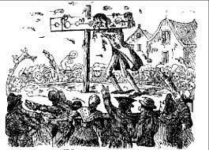
x
Listen to the News or read a Newspaper (ask a grown up to help you), make notes on any crimes you find and how the criminal was punished.
Date:_________________
From your learning in class, create a 3D model of a historic punishment using materials you can find e.g. sticks or toy bricks.
Date:_________________
Design a wanted poster, who are they and what crime have they committed?
Date:_________________
Spring 1
‘Crime and Punishment’

Write a diary entry from the point of view of an escaped convict, how would they be feeling? What crime have they committed? Are they guilty?
Date:_________________
Using an old boot as a portal key, write a short story where you are transported to the scene of a crime. Describe the setting using as much detail as possible.
Date:_________________
Create a ‘spot the difference’ picture of a medieval trial and a modern one. How many differences are there to find?
Date:_________________
Design and create your own police uniform, what features would you include? Label your design.
Date:_________________
You and your friends have just discovered a new country, make a set of laws to keep your citizens safe.
Date:_________________
Homework due in on Wednesday.
To do:
- One topic activity.
- MyMaths tasks as set.
- Revise times tables.
- Weekly spellings.
- Reading.

