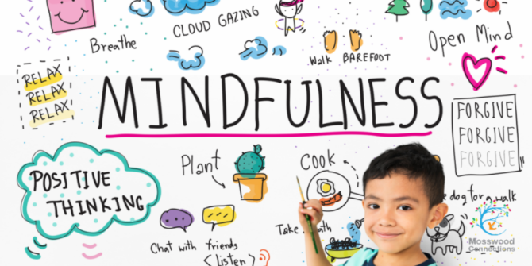


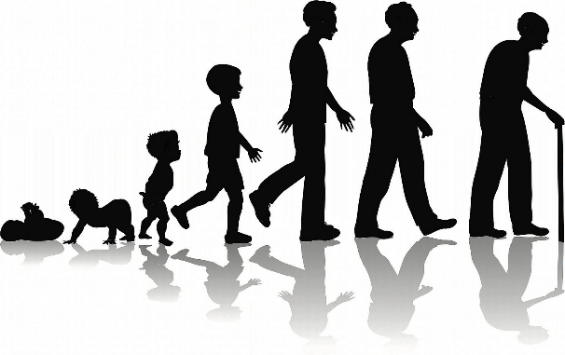
x
Inline with our class novel, Room 13, write a nightmare sequence. Conclude it with the character waking up and not knowing whether it was a dream or not…
Underline every time you use figurative language.
Date:_______________________
Create a poster to promote positivity in the classroom.
Date:______________________
Keep a mindfulness diary for one week. Write down 3 things you are grateful for each day.
Date:_____________________
Write a poem about being human. You can choose the style, but be sure to include how it feels to be human.
Date:_____________________
Investigate whether male babies are heavier than females. Gather as much data as you can from family and friends and present your findings in a table. Be sure to include your prediction and a conclusion.
Date:__________________________
Homework due in on Wednesday.
To do:
- One topic activity.
- MyMaths tasks as set.
- Revise times tables.
- Spellings.
- Reading.
Create a self-portrait. Use any medium you like – be creative! Will you choose realism or abstract?
Date:_____________________
Create a comic strip to show the stages of human development.
Date:_________________________
Using everything you learnt about vector drawing in our computing lessons, create a vector drawing of a famous person who has influenced you.
Date:__________________________
Summer 2
‘Being Human’

