**PTFA Annual General Meeting**

**Thursday 19th September @ 7.30**

* **Attendees:** Mr Manning, Mr Pascoe, Lucy Stafford, Rebecca Wells, Hannah Hall, Chrissie Hall Louise Cole, Eleanor Badran, Jenny Facey, Ellie Andrews, Bethan Hunter, Sarah McLachlan and Billie Wright with Sam Watt dialled in via Team’s call.
* **Apologies:** Sarah Gooch, Rachel Evans & Becca Weston
* **Notice of AGM & Quorum:** confirmed

**President’s report (Mr Manning)**

|  |
| --- |
| I would like to congratulate the PTFA committee and volunteers for the hugely successful year.   The addition of the clamber stack and trim trail has really enhanced the playtime experiences for all children.   The ongoing support for class trips and residentials has helped all children at some point in the year.  I would also like to say a huge thank you for supporting the extra curricular events, such as the pantomime, African drumming and visiting theatre productions.   I am really excited about the year ahead with the continued support of the PTFA. |

**Chair’s report (Rebecca Wells)**

|  |
| --- |
| I would like to thank all of the members of the PTFA for all their hard work and dedication over the last year, enabling us to achieve such amazing results!! Each person has different pressures on their time so any time that is given to the PTFA is greatly appreciated, and every individual brings their own unique set of skills and abilities! Also, thanks need to go to every parent, family member, carer or member of the local community that has donated time or gifts/donations, as well as their support for our events and activities. Whether it is half an hour on a stall (and we know how important those are!), a connection to a potential sponsor, collecting raffle prizes, washing up after an event, or attending an event it is all really vital to reach the end result! The treasurer’s report will detail more of how we have spent the money raised, but I will mention the two main projects that we managed to fund this year. The big one is of course the new clamber stack and trim trail; the success of which can be measured by the fact that there has to be timetabled use for each class! They are being very much enjoyed by the children! The second is the new hall floor, which of course benefits the children every day! Along with our regular events and funds to school, we have added a few new additions to our repertoire, including the funding of the Year 6 hoodies so that no child is without a hoodie for their London Residential. We also have adopted the new Parentkind constitution following our EGM, making sure that the administration of the PTFA as a charity is all being managed correctly. A special thanks to Chrissie and Louise for working their way through all the small print! The unique nature of the PTFA is why we can achieve so much – well done everyone!! |

**Treasurer’s report 23/24 (Chrissie Hall)**

|  |
| --- |
| Gorsley Goffs PTFA is a registered charity whose financial year ran from September 2023 to August 2024. The accounts are published to the Charity Commission.  This financial period started strongly with £29,607.01 of cleared funds in the account. Throughout the year we were able to pass over a total of £43,220.65 to school. This covered donations towards the main hall floor, Play areas, walkie talkies, new classroom chairs, polytunnel and forest school supplies and a new roof for the forest school cabin, school trips and treats, dictionaries and thesaurus, a visit from an African Drumming Band, supplies for a fish tank and much more!  Fundraising events this year included a sponsored bounce, wreath making, Christmas Bazaar, quiz night, Easter Breakfast, Summer Fete and 2 school discos. Our fundraising events raised a combined total of over £18,000.  £600.46 has been raised through second hand uniform sales.  We are very grateful to have received donations from local events, businesses and charities.  £1000 Mews Auction.  £1500 Much Marcle Steam Rally  £1500 Tesco  £500 Ecclesiastical   £723 Charities Aid Foundation  £300 Linton Summer Sessions  £500 Newent Runners   £50 Gorsley Gardening club  £100 Year 6 Parents  We also managed to secure £1000 of Sponsorship for our Summer Fete.  We have a clothing bank with Roberts Recycling which raised us £154.40 throughout this period.  For the coming financial year we have started with £13,718.06 of cleared funds in the account. We have ring fenced £6000 of this for our pre-agreed allocation to school- allowing £500 more than previous years due to the cost of living increases and increased pupil numbers- however we will discuss this allocation at our first meeting to make sure it is still appropriate recognising that it hasn’t been reviewed since 2021. We will continue to ensure there is a minimum of £1000 in the account to allow planning of future events. We look forward to supporting Gorsley Goffs Primary School for the 2024-2025 school year.  Thank you to all those who have contributed to our events and supported our PTFA. |

**Elections of Committee Members:**

The following people were elected following the nomination and seconding process:

• **Chair** – Hannah Hall

• **Vice Chair** – Eleanor Badran

• **Treasurer** – Chrissie Hall

* Confirmed that we will approach Ian Kettle to ask if he will audit accounts again this coming year.

• Members - Louise Cole, Eleanor, Bethan Hunter, Billie Wright, Sarah McLachlan and Jenny Facey

• President & School Liaison – Mr Pascoe

**Committee Meeting**

**Thursday 19th September @ 8pm**

* **Attendees:** Mr Manning, Mr Pascoe, Hannah Hall, Chrissie Hall, Louise Cole, Eleanor Badran, Jenny Facey, Ellie Andrews, Bethan Hunter, Sarah McLachlan and Billie Wright
* **Apologies:** Sarah Gooch & Becca Weston

1. **Key Dates**

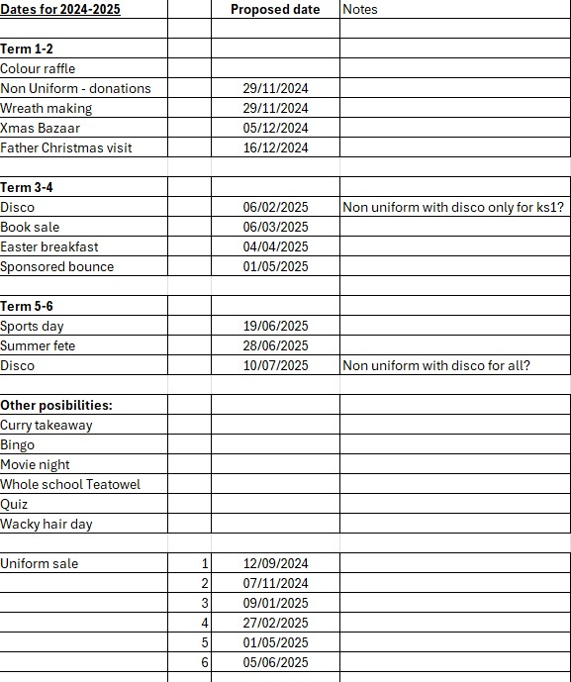

1. Books @ Christmas- discussed opportunity to change how we manage the selection so that we ease the burden of teachers having to select a book for every pupil. PTFA looking into the opportunity to allow children to select a book instead.
2. Christmas cards- confirmed that due to the minimal income and additional burden (in Sept), PTFA will not be running the Christmas card purchase scheme this year. It was noted that pupils usually make Christmas cards in class with teacher during Dec so appears to be double effort on cards occurring. PTFA looking into alternative options for Christmas craft opportunities.
3. October colour raffle- discussed the rainbow raffle concept as a replacement for class cake sales during the year. Confirmed that we could run this in October to ensure that each class has ample time to spend their money during the school year. Each class will get an equal amount however PTFA will reward the class with the best hamper by topping up the amount by £50. Cake sales will still run at opportune times throughout the year but not by each class as we did last year.
4. Hot Choc Mondays- looking to run a number of these sessions in the school yard as the weather gets colder. Dates to be confirmed with school.
5. Tibberton Happy Circus- Tibberton PTFA have got in touch and confirmed that they will donate £1 for every ticket sold that references GGS. Confirmed that we would share opportunity with parents. HH attending as a volunteer. Possible opportunity for future.
6. School uniform sale- will run first Thursday back after every holiday.
7. Possible School requests- Mr Manning

|  |
| --- |
| **Possible school requests:**   * A request to consider increasing the £15 per child support for trips etc.  We have noticed, even in the last 12 months, an increase in venue costs and transport.  An increase would be welcomed by all parents and staff. * 210 pupils at £20 - £4200 * A request to support IT projects in the school.  For example, increase the number of iPads and Bluetooth keyboards, rather than laptops.  This could also include charging/storage stations.   The school are looking to use their IT budget to commence a program of replacing old projectors and boards with modern clear touch screens (like those in Acorns and Kempley class) * iPads £250 each (20 more if possible) - £5000 * 2 x Charging station £50 each * EYFS outdoor shelter/classroom is in desperate need of replacement.  This probably won’t fit within the PTFA remit…but worth asking. * £8500 for a new structure * £6000 to repair, seal, clad, reroof, the existing structure. * Could we enhance the area around the outdoor classroom?   Power? * The school staging is currently supplemented by staging from the church.  Could we at least see if there are volunteers (with a van/pick up) who would be able to take this back and forwards to the church.  Alternatively, we could look at purchasing the short fall. * 10 frames and 4 tops - £1750 * A request to purchase a replacement storage shed for playground equipment and outdoor PE resources. * Shed £500 approximately * Ongoing support with any other extra-curricular experiences * Art experience for whole school – school hall * Sensory garden – develop the wildlife area so it becomes accessible during break times etc. * Gate going into field from car park for events? * Some new football posts and nets? |

1. Confirmed that we would increase the yearly allocation to £7397
2. Next meeting- Tuesday 22nd October 7:30pm