

Name:
Age:
School:

Physical Activity and Well-being Planner

Mission Statement

Prostars aspires to develop & improve the delivery of physical literacy, with opportunities for all to compete & participate in PE & School Sport.
We have created our Physical Activity Planner for children to complete when they are not in school. Our planner offers a variety of activities your child can complete to help track their progress to leading a healthy lifestyle, being active and to enjoy the holidays!
We hope you enjoy our pack!
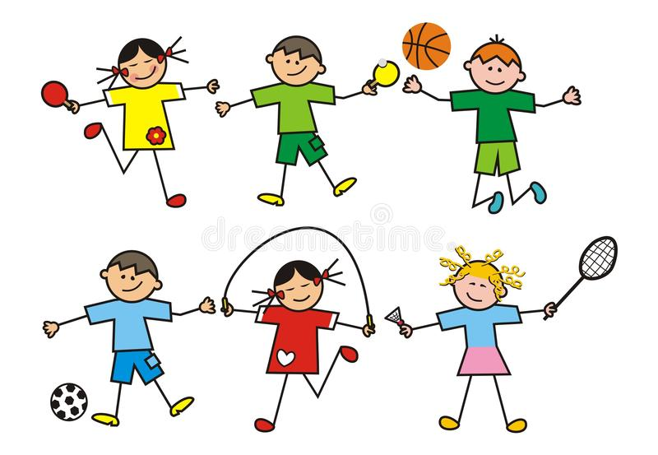

Contents Page:
Pages
1. Colour our logo
2. Prostars Quiz 1
3. Prostars Quiz 2
4-7. Food logs
8. Prostars Activity Log
9-11. Picture Log
12-13. Well-Being Diary
14-15. Mindfulness Colouring
16. Activity Monopoly
17. Summary

Help us colour in our logo!


Take a picture and post it on our Facebook page – search Prostars to find us!

Prostars Sports Quiz 1
- How many players are there in a basketball side?
- Which wizarding sport played on broomsticks does Harry Potter play?
- Name the golfer who first name is the same as a big cat?
- Which country does footballer Lionel Messi play for?
- How many rings are there on the Olympic flag?
- Which sport did Johnny Wilkinson and Martin Johnson play?
- Which type of swimming stroke has the same name as a flying insect?
- Is Mo Farah a champion at athletics, football, swimming or tennis?
- What is the name of the hard rubber disc players hit in hockey?
- A caddy is the person who carries a player's bag in which sport?
- Which important horse race is jumped over fences at Aintree and was once won by Red Rum?
- How many goals are scored if a player has a hat-trick?
Prostars Sports Quiz 2
- In which football stadium do Manchester United play all their home matches?
- In the Olympics you get a gold medal for coming first, what do you get for coming second and third (two answers)?
- In which country did the Olympic games originate?
- Andy Murray is a champion in which sport?
- What sort of snack food does former footballer Gary Lineker advertise on television?
- What do teams pull in a game of tug of war?
- What colour balls are worth one point in a game of snooker?
- How many vertical wooden stumps make up a cricket wicket?
- What do players hit in the game badminton?
- What name is given to the spear like object thrown in athletics at the Olympics?
- Michael Phelps has won the most Olympic medals ever; which sport did he compete in?
- Which football team are also called The Gunners?

Week of  ……………. | Breakfast | Lunch | Dinner | Snacks | Water Log | Active Minutes
Monday
Tuesday
Wednesday
Thursday
Friday
Saturday
Sunday
Keep on track with your weekly food and fitness log!

Keep on track with your weekly food and fitness log!
Week of  ……………. | Breakfast | Lunch | Dinner | Snacks | Water Log | Active Minutes
Monday
Tuesday
Wednesday
Thursday
Friday
Saturday
Sunday

Keep on track with your weekly food and fitness log!
Week of  ……………. | Breakfast | Lunch | Dinner | Snacks | Water Log | Active Minutes
Monday
Tuesday
Wednesday
Thursday
Friday
Saturday
Sunday

Keep on track with your weekly food and fitness log!
Week of  ……………. | Breakfast | Lunch | Dinner | Snacks | Water Log | Active Minutes
Monday
Tuesday
Wednesday
Thursday
Friday
Saturday
Sunday

Prostars Activity Log
 | Monday |  |  |  | Tuesday |  |  |  | Wednesday |  |  |  | Thursday |  | Friday
Activity | P.E with Joe Wicks Live on Youtube –  Personal trainer Joe Wicks is going live on YouTube every morning at 9am Monday- Friday, delivering fun home workouts for children.  Don’t worry if you miss the workout as he has loads of videos on his channel you can get involved with.  https://www.youtube.com/channel/UCAxW1XT0iEJo0TYlRfn6rYQ |  |  |  | Hand Eye Coordination –  Follow The link to challenge yourself in these catch tests.  Practice each one for two minutes.  https://www.youtube.com/watch?v=T3kvqbiohC8 |  |  |  | Skill School:  Week 1 – Frying pan challenge  How many times can you keep a ball of paper up with a frying pan.  Week 2- Toilet roll challenge  Using any part of your body how many times can you strike a toilet roll without it touching the floor.  Week 3 – Tea bag challenge  Can you throw a teabag into a mug from 2m away.  Week 4 – Laundry basket Baseball  Can you strike a ball of paper into a basket using a shoe as a bat |  |  |  | Let’s Move!  10, 000 steps or Increase your N.E.A.T (Non-Exercise Activity Thermogenesis)  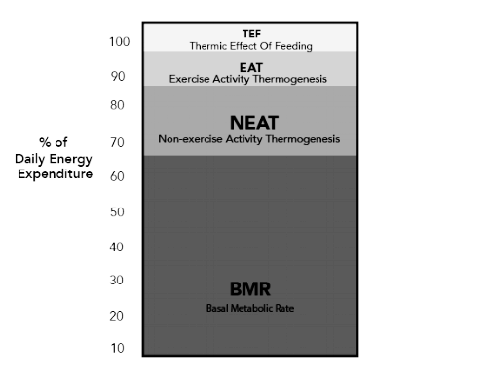  NEAT is the energy expended for everything we do that is not sleeping, eating or sports-like exercise.  What have you done today to increase your NEAT?  How many steps have you done? |  | Yoga  Search ‘Yoga for Children’ on YouTube and pick one of the many videos to choose from.  Feel the benefits of yoga, strengthening and stretching your body as well as relaxing breathing techniques that will have a positive effect on you.
How to show progression | Time how long you managed to last without having a break and  Give your time below. |  |  |  | How many challenges did you manage to complete for 2 minutes without dropping the ball |  |  |  | Fill in the boxes below with your score |  |  |  | Examples:  -10,000 steps  - Housework  - Gardening  - Walk the dog  - Helped with the shopping  - Played games that involve moving |  | Write down your favourite new yoga pose you’ve learnt this week.
Weeks 1-4

Take a photo or draw a picture!
Here is where you can keep all your pictures of you being active and completing your activity planner!

Take a photo or draw a picture!
Here is where you can keep all your pictures of you being active and completing your activity planner!

Take a photo or draw a picture!
Here is where you can keep all your pictures of you being active and completing your activity planner!

Well-being Diary
We at Prostars place huge value on our well-being. Use this space to collect your thoughts and feelings and tell us how being physically active has helped you!
Week 1
Week 2

Well-being Diary
We at Prostars place huge value on our well-being. Use this space to collect your thoughts and feelings and tell us how being physically active has helped you!
Week 3

Week 4


Mindfulness Colouring
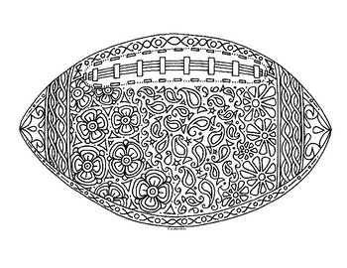
Mindfulness Colouring

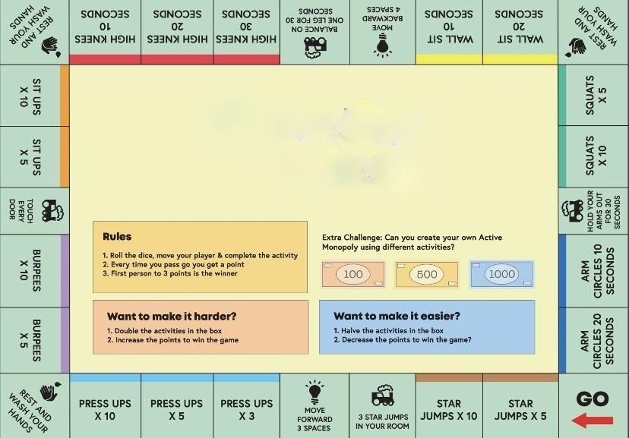
Prostars Fitness Monopoly
Give this activity ago on your own or with a family member!
Congratulations!
You have completed the Prostars Physical Activity planner!
We would love to hear what you thought of our planner so please if you can leave us a review on our Facebook page! (Search ‘Prostars’ to find us).
Can we take this opportunity to say a huge thank you from all of us at Prostars, it has been great to be on this journey with you and we hope you continue to lead a healthy lifestyle and stay active!
If you want to get in contact please email us at
Jfowler.prostars.fse@gmail.com

Jcarter.fse@gmail.com

