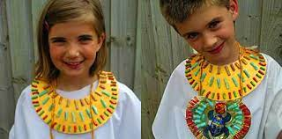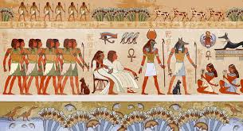

Create your own Egyptian God and write a character description about them.

Date:­­­­_________________

After working as part of an excavation team, you uncover precious Egyptian artefacts. Write a diary entry about your day.

Date:­­­­_________________

Research an ancient Egyptian God of your choice and create a ‘Top Trumps’ card for them.

Date:­­­­_________________

Design and create your own ancient Egyptian jewelry and/or headpiece. Get creative!

Date:­­­­_________________

Design a poster with your name in hieroglyphics.

Date:­­­­_________________

Create a persuasive leaflet to encourage people to visit Egypt, what things should they visit?

Date:­­­­_________________

Homework due in on Mondays.

To do:

* One topic activity.
* MyMaths set tasks.
* Spellings.
* Reading (aim for 10 mins a day)

You have discovered a hidden tomb! Draw a map and write a set of instructions to guide you through – avoid the traps!

Date:­­­­_________________

Autumn 2

‘Walk like an Egyptian’

Using the words ‘ancient Egypt’ write an acrostic poem.

Date:­­­­_________________