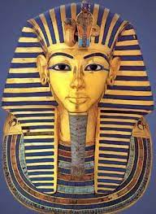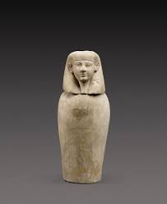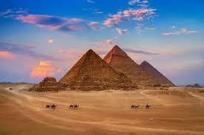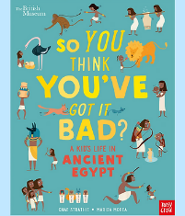

Maths

This half term we will be revisiting multiplication and division as well as fractions.

We will follow White Rose Maths and use a process of small step learning starting with multiples, factors and prime numbers. We will then multiple and divide by 10, 100 and 1000.

As we move onto fractions, we will begin with finding and recognising equivalent fractions. Then we will explore improper fractions and mixed number fractions, comparing and ordering fractions followed by adding and subtracting.

PSHE and RE

‘Why is the Torah so important to Jewish people?’ We will explore differences between the Jewish religion and Christianity, take a virtual visit to a Synagogue and discover some of the important stories within the Torah. We will end half term by exploring the theme of homelessness in the Christmas story.

Our PSHE lessons will focus on ‘Celebrating difference’

History/Geography

We will begin our topic by using

atlases to research and locate

Egypt.

We will create a timeline of

ancient Egypt and use text books to add additional information.

We will discover why the river Nile was and remains so important to Egypt. We will research different areas of ancient Egypt and create a whole class podcast.

PE

Indoor - Dance

Outdoor – Football

DT

We will start our first DT project by discovering the inventions of the ancient Egyptians. We will create a bag decorated with hieroglyphs. We will research current products, create our own design, make, then evaluate our finished bag.

Computing

We will develop our understanding of computer systems and how information is transferred between systems and devices. We will create a class podcast based on our topic learning.

Music and Drama

We will be creating and performing class and group compositions, the purpose for compositions will be ‘an Egyptian ceremonial piece’, using untuned and ultimately tuned percussion. We will recap note values, extend to pulse, syllable and ostinato rhythms to create a rhythmically layered piece.

Science

As scientists we will be looking at forces with our key scientist this half term being Sir Isaac Newton. We will look at gravity, air resistance, friction and water resistance through a series of investigations. We will end out topic by exploring how some mechanisms can allow a smaller force to have a greater effect.

Autumn 2

‘Walk like an Egyptian’

English

This half term we will begin by looking at setting descriptions based on a portal story. We will use our experience of discovering Tutankhamun’s tomb during our Egyptian Extravaganza to write a newspaper article followed by revisiting instruction writing.

Spellings will be changed weekly with a quiz every Friday.

Modern Foreign Languages

In French we will be learning about the weather.