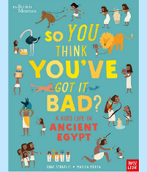
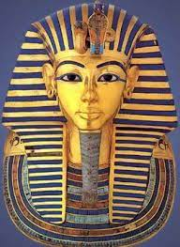
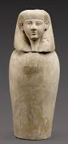
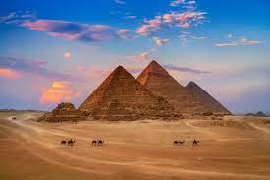
Music and Drama
As Musicians we will be creating and performing class and group compositions, the purpose for compositions will be ‘an Egyptian ceremonial piece’, using untuned and ultimately tuned percussion.
As Dramatists this term we will be story telling through role play and taking part in pair and group improvisations.

History/Geography
We will begin our topic by using
atlases to research and locate
Egypt.
We will create a timeline of
ancient Egypt and use text books to add additional information.
We will discover why the river Nile was and remains so important to Egypt. We will research what life was like in ancient Egypt across society.
Modern Foreign Languages
As linguists we in French we will be learning about the weather.

Science
As Scientists we will be looking at forces with our key scientist this half term being Sir Isaac Newton. We will look at gravity, air resistance, friction and water resistance through a series of investigations. We will end our topic by exploring how some mechanisms can allow a smaller force to have a greater effect and create shadufs.

PSHE and RE
Our PSHE lessons will focus on ‘Being me in my world’ this half term.
In RE we will be joined by Charlotte Newton from ‘Walk through the Bible’ where we will be exploring the teachings of the Old Testament.

Computing
We will develop our understanding of computer systems and how information is transferred between systems and devices. We will create a class podcast based on our topic learning.

Maths
As Mathematicians we will be building on our Place Value knowledge at the start of Year 5. Firstly, looking at Roman Numerals up to 1000 then numbers within 1,000,000. We will be ordering, comparing and rounding numbers following the White Rose Maths scheme.
We will then explore addition and subtraction with more than 4 digits, inverse operations and missing number problems to strengthen our understanding.

Art
As Artists this half term we will be exploring Ancient Egyptian artwork, focusing on the depiction of Pharaohs. We will create our own papyrus to use in our final piece where we will explore the work of modern-day artists Gerhard Richter and Valeria Trasatti to create self portraits of ourselves as Pharaohs. We will also make our own cartouche.

Autumn 1
‘Walk like an Egyptian’
PE
Indoor - We will be focusing on ball skills and understanding ways to assess performance.
Outdoor – Hockey

English
As Writers we will begin by looking at setting descriptions based on a portal story. We will revisit instruction writing when looking at the mummification process and use our experience of discovering Tutankhamun’s tomb during our Egyptian Extravaganza to write a newspaper article.
Spellings will be changed weekly with a quiz every Friday.

