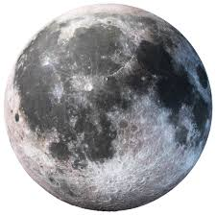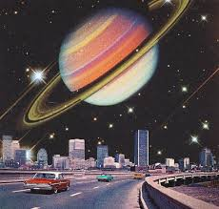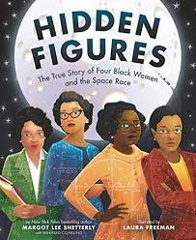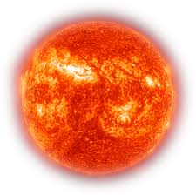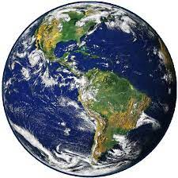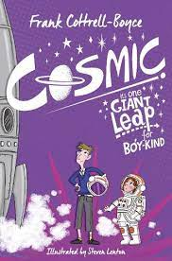

Music and Drama

Using Holst's 'Planet Suite' we will explore different art forms as a creative response. We will use untuned and tuned sound, including IPAD technology.

In drama we will focus on persuasive speech writing by writing and performing our own.

Computing

We will develop our understanding of computer systems and how information is transferred between systems and devices.

Science

As Scientists we will learn about the movement of Earth and other planets relative to the Sun by understanding their order and how they move. We will look at the Earth’s rotation to explain day and night.

History/Geography

As Historians we will learn about

the Space Race and find out about Cecilia Payne. We will focus on interpretation, chronological understanding and communication to develop our enquiry skills.

In Geography we will compare the UK with Australia to help us understand day and night.

PSHE and RE

Our PSHE lessons will focus on ‘Being me in my world’.

In RE we will be exploring the question ‘What does it mean if God is holy and loving?’.

PE

Indoor - We will be focusing on ball skills and understanding ways to assess performance.

Outdoor – Hockey.

Art

We’ll be exploring

‘Retro-Futurism’ and use mixed media to create a view from Space.

Artists: Simon Stalenhag, Peter Elson.

Autumn 1

‘To infinity and beyond!’

English

This half term we will be exploring non-chronological reports, diary entries and persuasive writing in the form of a travel leaflet. Using our topic for inspiration we will be developing our skills of writing to

inform and persuade.

Spellings will be changed weekly

with a quiz every Friday.

Maths

We will be building on our Place Value knowledge at the start of Year 5. Firstly, looking at Roman Numerals up to 1000 then numbers within 1,000,000. We will be ordering, comparing and rounding numbers following the White Rose Maths scheme.

We will then explore addition and subtraction with more than 4 digits, inverse operations and missing number problems to strengthen understanding.

Modern Foreign Languages

In French we will be learning about the planets.